Website Bullshit

World History
I hope that we can all understand that the world existed before humans because it is about 4.5 billion years old, and the earliest fossils of life date back to 3.7 billion years ago. Homo Sapiens have been walking around since at least 300,000 years ago, but what we would call modern humans only really occurred 164,000 years ago.
Which is where Human History technically starts. Very little of Human History is documented, and within those documents very few tell the full story.
To start the exploration of human history we start with the land

World History Through Maps
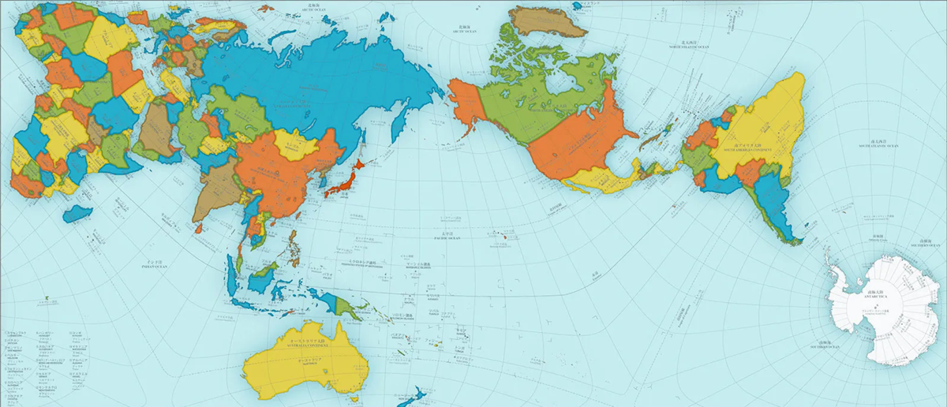AuthaGraph, a world map by Designer Hajime Narukawa
To understand human history around the world, you must have an accurate map. Turning a spherical planet into a flat map that is 100% accurate is not actually possible, but AuthaGraph designed by Hajime Narukawa gets very close.
The narukawa lab website has a tutorial on how to recreate this map on a smaller scale (Click Here)
Why Maps Lie: To learn why world maps are inaccurate and what affect that has had on our world view (Click Here)
Humans Place Among Nature
- Resources of the World
Humans Place Amongst Each other
- Common societal ideas
- Human societies
Humans Place Amongst Themselves
- Culture

World Stories
Every story has a purpose, and that purpose is meant to appeal to a person's empathy, teaching them by using each individual's interpretation and feeling towards the story to cement a lesson.
Stories are the greatest way to revive humanity from accounts of human history that lack it.
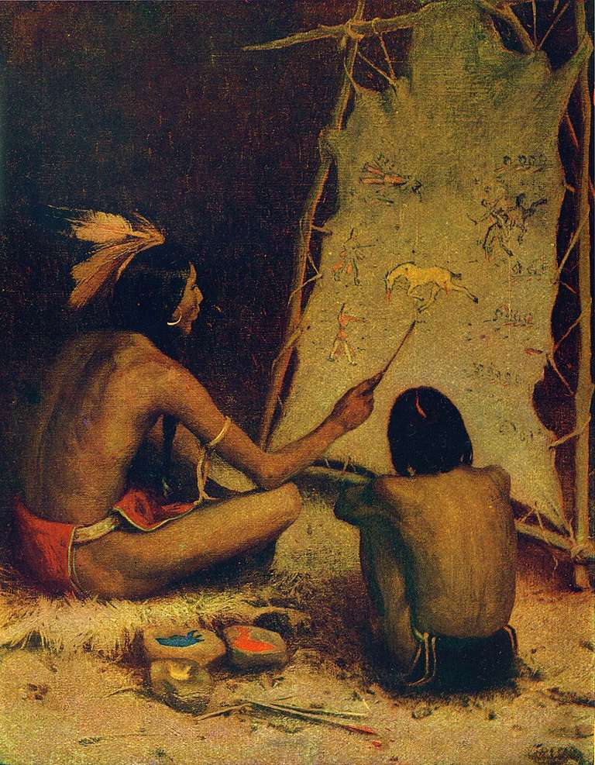The Historian; The Indian Artist is painting in sign language, on buckskin, the story of a battle with American Soldiers. 1902 by E. Irving Couse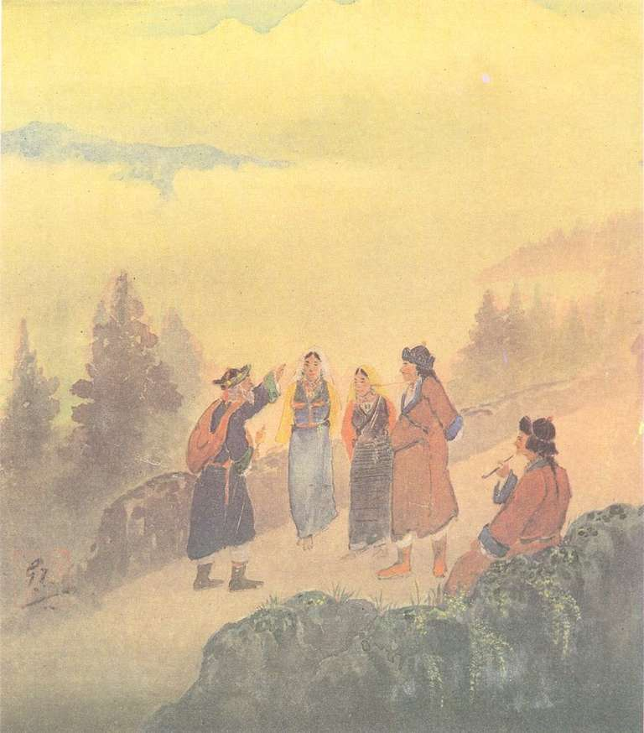Story Teller by Gaganendranath Tagore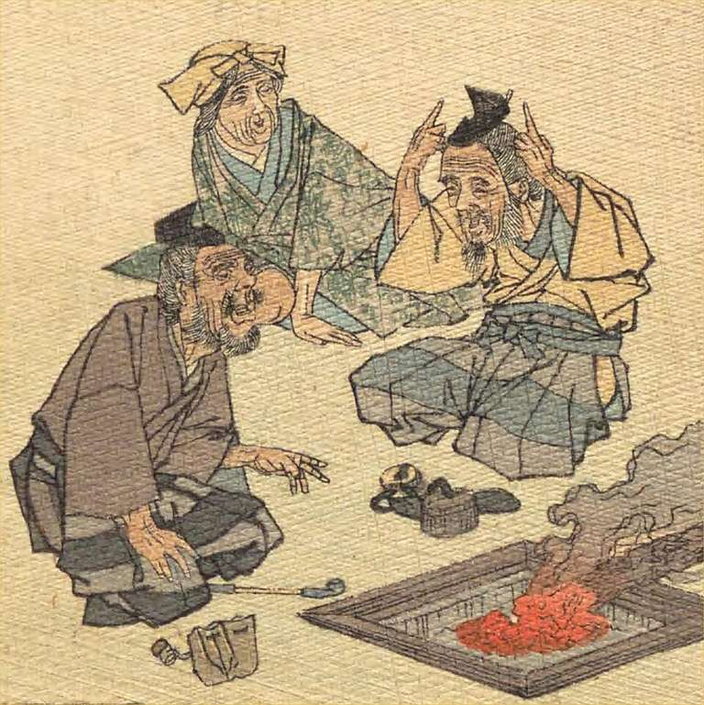Anonymous (illustr.) (1888) Hepburn, J. C. tr., , ed. The Old Man and the Devils, Japanese Fairy Tale Series, No. 17, Kobunsha

Stories = History
Much of the Western world has failed miserably in understanding the value of storytelling. Most simply put, the passing of accounts/narratives of an event from one person to another is History.
History is the human past, which can be depicted through:
- Written History(physical or digital): Books, Articles
- Visual History: Paintings, Pictures
- Oral History: Stories, Folklore, Legends
The Undead: A Buried History (Click Here)

Compare and Contrast of Each Form of History
The sharing of history is innately human, no matter what form it takes each are equally valuable in creating an accurate representation of an event from all sides.
Every account of history is inseparable from the following:
- Interpretation
- Narrative
- Subject to outside censorship
For further explanation behind blunt statements: The Guide to Understanding History (Click Here)

Two Types of Stories
Though Western sources often equate the two there are two vastly different types of stories:
- Fairy Tales
- Legends

Fairy Tale

Colonial Bastardization of Storytelling
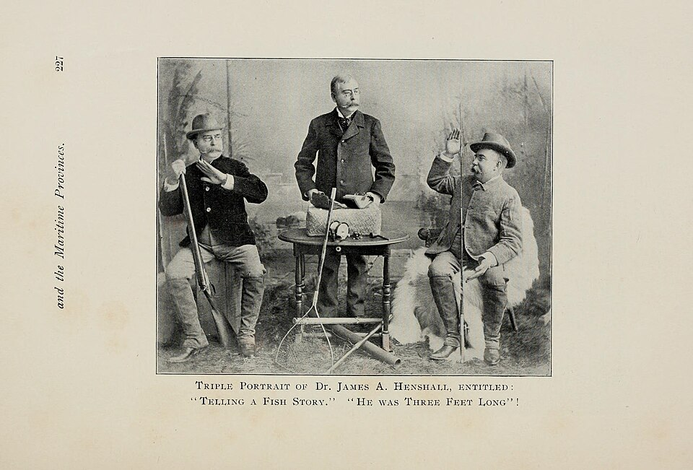Samuels, E. A. With rod and gun in New England and the maritime provinces. Boston: Samuels & Kimball, 1897.
Dismiss. Supress. Distort.
In the end replacing history altogether with colonial narratives.

Legend

Fairy Tale

Colonial Bastardization of Storytelling
Samuels, E. A. With rod and gun in New England and the maritime provinces. Boston: Samuels & Kimball, 1897.
Dismiss. Supress. Distort.
In the end replacing history altogether with colonial narratives.

Legend

The Undead: A Buried History
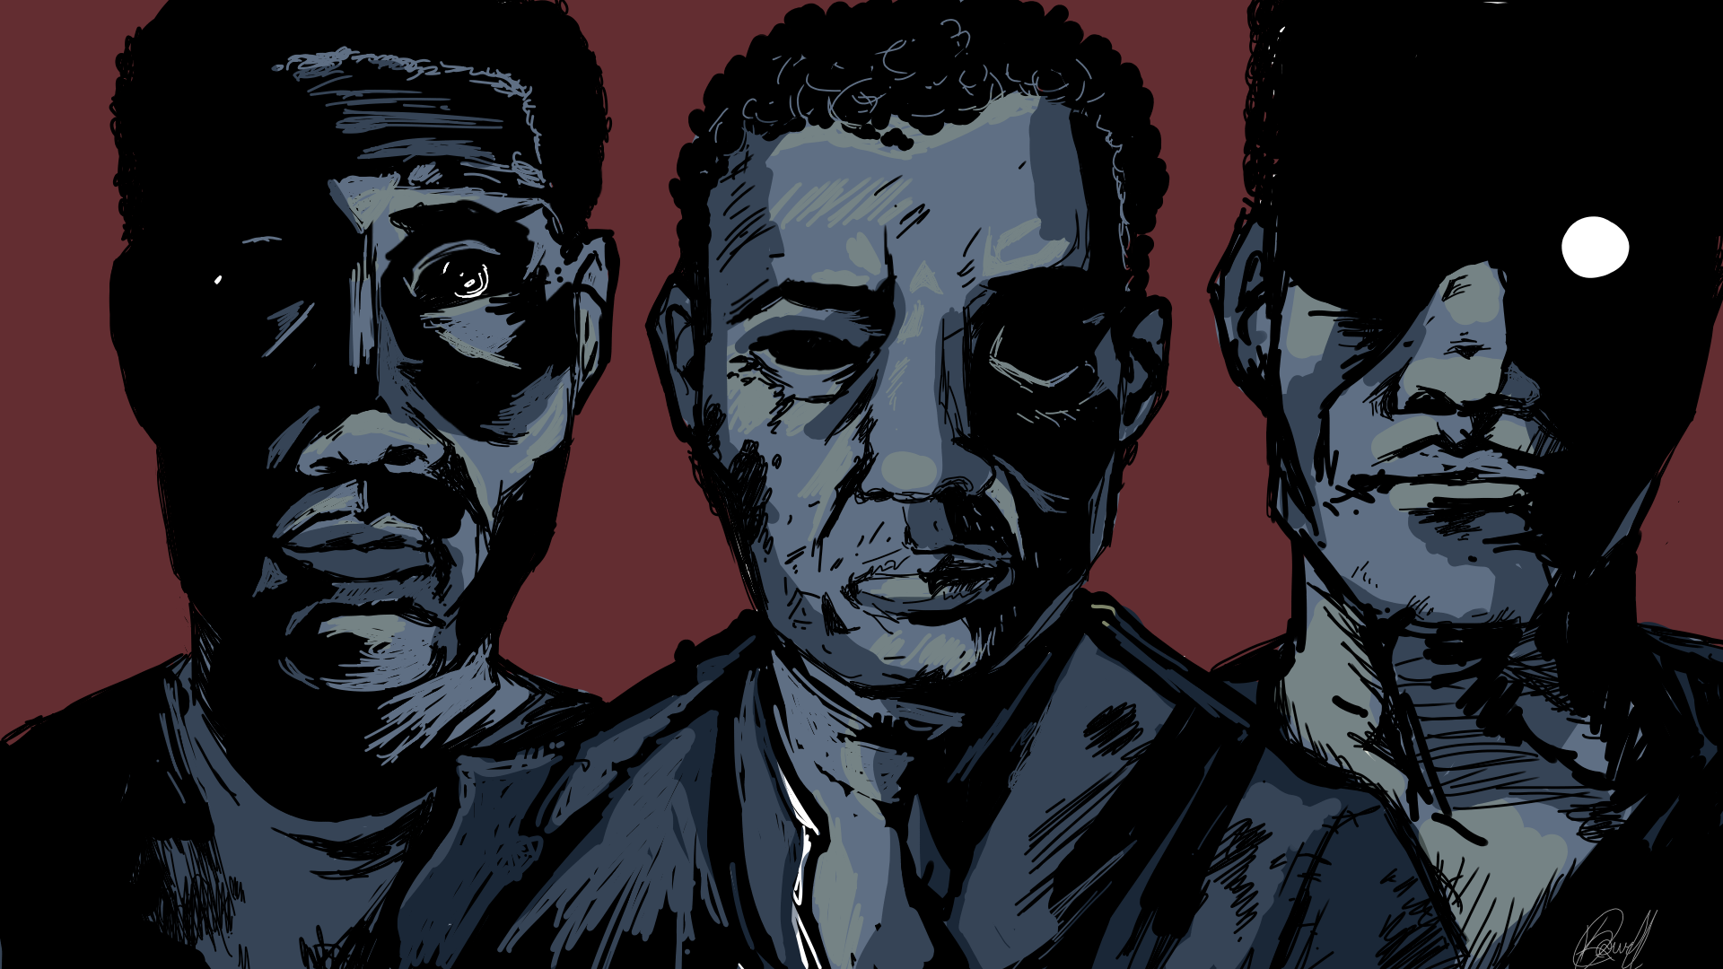
Stories of the dead doing things the dead aren’t supposed to do, like be alive, happens for many reasons and in many forms.
Often times when the West pictures the Undead, the Romero Zombie comes to mind. One might think that the near universal story trait of paleness would make the West feel included but...

Not Even the Zombi is the Zombie
The Western perception of the undead centres on the Zombie, but the westernized version of the Zombie is one of the greatest examples of how stories are colonized.
The definition of the Western version of the Zombie is:
(In stories) a frightening creature that is a dead person who has been brought back to life, but without human qualities. Zombies are not able to think and they are often shown as attacking and eating human beings
Cambridge Dictionary (Digital)
I would define the Zombie based off the original Zombi as a specific category of undead, where:
The individuals has complete loss of ability to self actualize in a world where basic needs and psychological needs are taken away. Which leaves only the basic biological survival mechanisms of the human species intact.
The Guide to Understanding the Zombi (Click Me)

Who Are The Undead?
So if the 'Zombie' isn't even the Zombi, then who are the Undead?
To think that the only type of Undead is Zombie is bamboozling because essentially every culture has some sort of flavour corpse both sickly and sweet.
The Undead Forms and What They Stand For

The Thesis:
There are two generalized situations where the dead have historically risen.
- The undead rise up when humanity's dignity is stolen by those who lack it.
And…
- When people feel that nature is inhibiting their ability to follow ceremonies around preserving human dignity.
And everything else falls into the category of stories that have been changed so drastically, by those with ulterior motives, that they are no longer representative of the culture.

Why The Undead Invade The Earth
The whole point of the undead is that they lack human dignity, the sense of self, and are meant to disgust us in some way, and disgust is a universal emotion.
However, what we are disgusted by is subjective to the culture we grow up in.
As Valerie Curtis and Adam Brian’s article “is Dirt, Disgust, and Disease: Is Hygiene in Our Genes?” explains through tables:
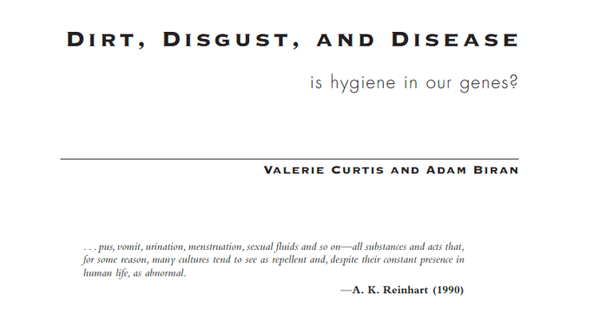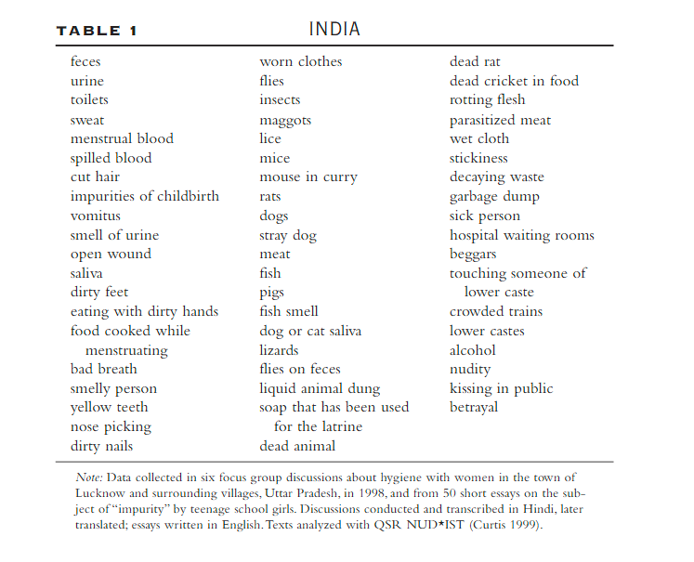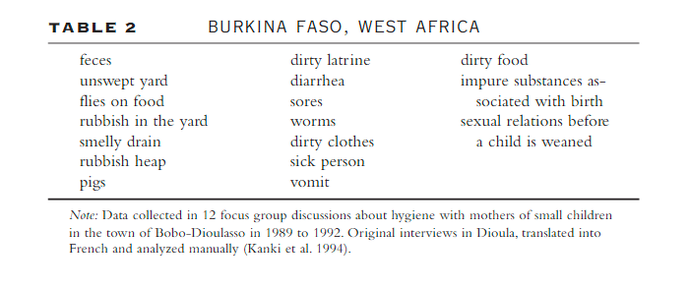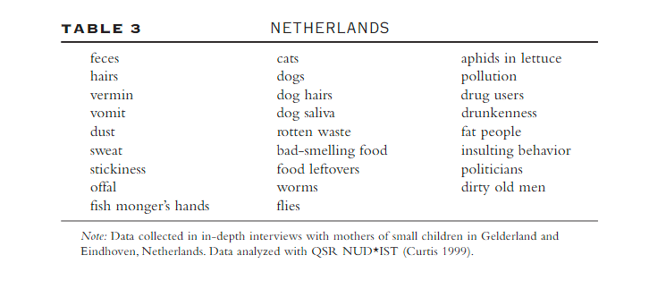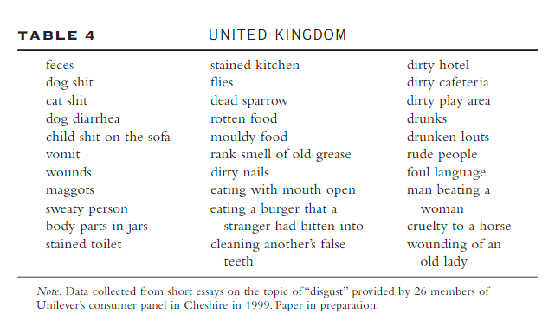
The Common Five Factors that Elicit Disgust:
- Bodily excretions and body parts
- Decay and spoiled food
- Particular living creatures
- Certain categories of “other people”
- Violations of morality or social norms.
The Undead Meant to Disgust

Luckily for interviewing people in the 1990’s (especially the UK) the “Certain categories” of “other people” is less about saying “ew melanin” and more so saying “ew financial struggle”.
Certain categories of other people are also found disgusting, notably those who are perceived as being either in poor health, of lower social status, contaminated by contact with a disgusting substance, or immoral in their behavior.
Valerie Curtis
That just sounds like upper class jargon before they get eaten by the lower class.
The best way to stop a cannibal is by Eating them yourself.
Now we're in the classism rabbit hole...

Even the Undead Can Be Classist
But how does classism and the undead connect, other than eating the rich?
Well, when everything else in life is sucking an absurd amount of ass on a historical level, the dead might start rising too. Classism is usually the background situation for who is going to be affected most by tragedy, and thus be the ones to pass on the legends of the living dead.
- The Zombie Vampires around the 18th century mostly affected the poor working class people, in communities without the resources to determine cause of death, so the cause of death became whimsical and overly religious.
- Bakekujira depicts the fear that their means of livelihood, which was whaling, would come back to haunt them. Though this was the depletion of a valuable resource they needed whaling to have the money to survive.
To break it down further, classism is based on the distribution and hoarding of resources, which subsequently relates to colonialism; and is also seen in flesh gobbling ghouls being a metaphor for gluttony.
A bunch of undead come from colonialism.
But in cultures not based in classism to the extent of Europe, will have legends based on lack of resources:
- Wendigo - Idea of starvation mixed with taboos around cannibalism.
- Qivittoq - For those who were a burden on the community in hard times.
The connection is also shown in the exception:
During the Plague, art of undead skeletons and ghouls attacked everyone from the highest of nobility to the lowliest of peasantry.
Because no matter how rich you are, everyone is equal in death.

Misinformation Information
It’s important to understand history when referencing creatures from cultures around the world. Any time a storyteller tells a story from a culture they are not of, there is automatic fair reason to question their narrative.
Just because there's a spookum in the woods doesn’t mean it’s a Wendigo or Skinwalker. At the end of the day the real monster was just your own misrepresentation of cultural ideas.
The Undead That Are Not Based on Actual Ancient Folklore

The Undead That Might Not Be Actual Ancient Folklore

There are many stories throughout the world of the humanoid dead who crave human flesh, that would be wrong to call the westernized “Zombie”.

Spirits?
Many undead are actually possessed by spirits, and it’s important to make that distinction or else you'd be changing history to suit western ideas rather than the facts.
Undead Spirits

To add additional clarity I’ll define spirits as directly related to spiritualism, and ghosts as anything you could see living in an 1800s Victorian mansion.
Ghosts are not corporeal.
Spirits can be corporeal under certain conditions.
And it's under those certain conditions of corporeal spirits that a lot of undead beings fall under. Because if we didn’t include spiritualism all the stories would pale in comparison, meaning they'd all centralize around Europe.
The Undead Based Around Colonial Slavery and Massacres

Which just furthers the idea of how connected history and stories of the undead truly are.
Powered by Publii

<details>
<summary>The Undead Forms and What They Stand For</summary>
<table style="border-collapse: collapse; width: 100%;" border="1">
<tbody>
<tr>
<td style="width: 57.7746%;" width="358"><strong><span style="color: #000000;"><span style="font-family: Bahnschrift, sans-serif;"><span style="font-size: medium;">The undead stand for…</span></span></span></strong></td>
<td style="width: 42.2254%;" width="261"><strong><span style="color: #000000;"><span style="font-family: Bahnschrift, sans-serif;"><span style="font-size: medium;">Undead forms:</span></span></span></strong></td>
</tr>
<tr>
<td style="width: 57.7746%;" width="358"><span style="color: #000000;"><span style="font-family: Bahnschrift, sans-serif;"><span style="font-size: medium;">American Occupation of Haiti</span></span></span></td>
<td style="width: 42.2254%;" width="261"><span style="color: #000000;"><span style="font-family: Bahnschrift, sans-serif;"><span style="font-size: medium;"><i>Zombi</i></span></span></span></td>
</tr>
<tr>
<td style="width: 57.7746%;" width="358"><span style="color: #000000;"><span style="font-family: Bahnschrift, sans-serif;"><span style="font-size: medium;">Violent acts done by Spaniards</span></span></span></td>
<td style="width: 42.2254%;" width="261"><span style="color: #000000;"><span style="font-family: Bahnschrift, sans-serif;"><span style="font-size: medium;">Pishtaco</span></span></span></td>
</tr>
<tr>
<td style="width: 57.7746%;" width="358"><span style="font-family: Bahnschrift, sans-serif;"><span style="color: #000000;"><span style="font-size: medium;">Violent groups like </span></span><span style="color: #000000;"><span style="font-size: medium;"><strong>Michael Leahy</strong></span></span><span style="color: #000000;">’</span><span style="color: #000000;"><span style="font-size: medium;">s</span></span></span></td>
<td style="width: 42.2254%;" width="261"><span style="color: #000000;"><span style="font-family: Bahnschrift, sans-serif;"><span style="font-size: medium;">Undead of Papua New Guinea</span></span></span></td>
</tr>
<tr>
<td style="width: 57.7746%;" width="358"><span style="color: #000000;"><span style="font-family: Bahnschrift, sans-serif;"><span style="font-size: medium;">Improper burial and ‘irrational death’</span></span></span></td>
<td style="width: 42.2254%;" width="261"><span style="color: #000000;"><span style="font-family: Bahnschrift, sans-serif;"><span style="font-size: medium;"><i>Razana</i></span></span></span></td>
</tr>
<tr>
<td style="width: 57.7746%;" width="358"><span style="color: #000000;"><span style="font-family: Bahnschrift, sans-serif;"><span style="font-size: medium;">Moral crimes</span></span></span></td>
<td style="width: 42.2254%;" width="261"><span style="color: #000000;"><span style="font-family: Bahnschrift, sans-serif;"><span style="font-size: medium;"><i>Corpo-Seco</i></span></span></span></td>
</tr>
<tr>
<td style="width: 57.7746%;" width="358"><span style="color: #000000;"><span style="font-family: Bahnschrift, sans-serif;"><span style="font-size: medium;">Unknown but likely Moral crimes</span></span></span></td>
<td style="width: 42.2254%;" width="261"><span style="color: #000000;"><span style="font-family: Bahnschrift, sans-serif;"><span style="font-size: medium;"><i>Kinòly</i></span></span></span></td>
</tr>
<tr>
<td style="width: 57.7746%;" width="358"><span style="color: #000000;"><span style="font-family: Bahnschrift, sans-serif;"><span style="font-size: medium;">Colonial wanton entitlement</span></span></span></td>
<td style="width: 42.2254%;" width="261"><span style="color: #000000;"><span style="font-family: Bahnschrift, sans-serif;"><span style="font-size: medium;"><i>El Silbón</i></span></span></span></td>
</tr>
<tr>
<td style="width: 57.7746%;" width="358"><span style="color: #000000;"><span style="font-family: Bahnschrift, sans-serif;"><span style="font-size: medium;">Lesson to move on</span></span></span></td>
<td style="width: 42.2254%;" width="261"><span style="color: #000000;"><span style="font-family: Bahnschrift, sans-serif;"><span style="font-size: medium;"><i>Hone Onna</i></span></span></span></td>
</tr>
<tr>
<td style="width: 57.7746%;" width="358"><span style="color: #000000;"><span style="font-family: Bahnschrift, sans-serif;"><span style="font-size: medium;">Infant mortality&nbsp;</span></span></span></td>
<td style="width: 42.2254%;" width="261"><span style="color: #000000;"><span style="font-family: Bahnschrift, sans-serif;"><span style="font-size: medium;"><i>Ubume</i></span></span></span></td>
</tr>
<tr>
<td style="width: 57.7746%;" width="358"><span style="color: #000000;"><span style="font-family: Bahnschrift, sans-serif;"><span style="font-size: medium;">Infant mortality and the fear of women</span></span></span></td>
<td style="width: 42.2254%;" width="261"><span style="color: #000000;"><span style="font-family: Bahnschrift, sans-serif;"><span style="font-size: medium;"><i>Pontianak</i></span></span></span></td>
</tr>
<tr>
<td style="width: 57.7746%;" width="358"><span style="color: #000000;"><span style="font-family: Bahnschrift, sans-serif;"><span style="font-size: medium;">Manipulation of legend</span></span></span></td>
<td style="width: 42.2254%;" width="261"><span style="color: #000000;"><span style="font-family: Bahnschrift, sans-serif;"><span style="font-size: medium;"><i>Phi Krasue</i></span></span></span></td>
</tr>
<tr>
<td style="width: 57.7746%;" width="358"><span style="color: #000000;"><span style="font-family: Bahnschrift, sans-serif;"><span style="font-size: medium;">Christian Spaniards fear of women's agency</span></span></span></td>
<td style="width: 42.2254%;" width="261"><span style="color: #000000;"><span style="font-family: Bahnschrift, sans-serif;"><span style="font-size: medium;"><i>Manananggal</i></span></span></span></td>
</tr>
<tr>
<td style="width: 57.7746%;" width="358"><span style="color: #000000;"><span style="font-family: Bahnschrift, sans-serif;"><span style="font-size: medium;">South-East Asian Gutty Women</span></span></span></td>
<td style="width: 42.2254%;" width="261"><span style="color: #000000;"><span style="font-family: Bahnschrift, sans-serif;"><span style="font-size: medium;"><i>Ahp&nbsp;</i></span></span></span></td>
</tr>
<tr>
<td style="width: 57.7746%;" width="358"><span style="color: #000000;"><span style="font-family: Bahnschrift, sans-serif;"><span style="font-size: medium;">South-East Asian Gutty Women</span></span></span></td>
<td style="width: 42.2254%;" width="261"><span style="color: #000000;"><span style="font-family: Bahnschrift, sans-serif;"><span style="font-size: medium;"><i>Leyak</i></span></span></span></td>
</tr>
<tr>
<td style="width: 57.7746%;" width="358"><span style="color: #000000;"><span style="font-family: Bahnschrift, sans-serif;"><span style="font-size: medium;">European Colonization</span></span></span></td>
<td style="width: 42.2254%;" width="261"><span style="color: #000000;"><span style="font-family: Bahnschrift, sans-serif;"><span style="font-size: medium;"><i>Mummy</i></span></span></span></td>
</tr>
<tr>
<td style="width: 57.7746%;" width="358"><span style="color: #000000;"><span style="font-family: Bahnschrift, sans-serif;"><span style="font-size: medium;">Nature’s violence and loss of self</span></span></span></td>
<td style="width: 42.2254%;" width="261"><span style="color: #000000;"><span style="font-family: Bahnschrift, sans-serif;"><span style="font-size: medium;"><i>Wendigo</i></span></span></span></td>
</tr>
<tr>
<td style="width: 57.7746%;" width="358"><span style="color: #000000;"><span style="font-family: Bahnschrift, sans-serif;"><span style="font-size: medium;">Nature’s violence&nbsp;</span></span></span></td>
<td style="width: 42.2254%;" width="261"><span style="color: #000000;"><span style="font-family: Bahnschrift, sans-serif;"><span style="font-size: medium;"><i>Qivittoq</i></span></span></span></td>
</tr>
<tr>
<td style="width: 57.7746%;" width="358"><span style="color: #000000;"><span style="font-family: Bahnschrift, sans-serif;"><span style="font-size: medium;">Manipulating christianity for land</span></span></span></td>
<td style="width: 42.2254%;" width="261"><span style="color: #000000;"><span style="font-family: Bahnschrift, sans-serif;"><span style="font-size: medium;">Hans Trapp</span></span></span></td>
</tr>
<tr>
<td style="width: 57.7746%;" width="358"><span style="color: #000000;"><span style="font-family: Bahnschrift, sans-serif;"><span style="font-size: medium;">Loss of identity</span></span></span></td>
<td style="width: 42.2254%;" width="261"><span style="color: #000000;"><span style="font-family: Bahnschrift, sans-serif;"><span style="font-size: medium;"><i>Dullahan</i></span></span></span></td>
</tr>
<tr>
<td style="width: 57.7746%;" width="358"><span style="color: #000000;"><span style="font-family: Bahnschrift, sans-serif;"><span style="font-size: medium;">Unfulfilled social role</span></span></span></td>
<td style="width: 42.2254%;" width="261"><span style="color: #000000;"><span style="font-family: Bahnschrift, sans-serif;"><span style="font-size: medium;"><i>Rusalka</i></span></span></span></td>
</tr>
<tr>
<td style="width: 57.7746%;" width="358"><span style="color: #000000;"><span style="font-family: Bahnschrift, sans-serif;"><span style="font-size: medium;">The lost coming home</span></span></span></td>
<td style="width: 42.2254%;" width="261"><span style="color: #000000;"><span style="font-family: Bahnschrift, sans-serif;"><span style="font-size: medium;">Moroi</span></span></span></td>
</tr>
<tr>
<td style="width: 57.7746%;" width="358"><span style="color: #000000;"><span style="font-family: Bahnschrift, sans-serif;"><span style="font-size: medium;">Embodiment of the fear of uncertainty</span></span></span></td>
<td style="width: 42.2254%;" width="261"><span style="color: #000000;"><span style="font-family: Bahnschrift, sans-serif;"><span style="font-size: medium;">Chötgör</span></span></span></td>
</tr>
<tr>
<td style="width: 57.7746%;" width="358"><span style="color: #000000;"><span style="font-family: Bahnschrift, sans-serif;"><span style="font-size: medium;">Mortasheen disease</span></span></span></td>
<td style="width: 42.2254%;" width="261"><span style="color: #000000;"><span style="font-family: Bahnschrift, sans-serif;"><span style="font-size: medium;"><i>Nuckelavee</i></span></span></span></td>
</tr>
<tr>
<td style="width: 57.7746%;" width="358"><span style="color: #000000;"><span style="font-family: Bahnschrift, sans-serif;"><span style="font-size: medium;">Baptism&nbsp;</span></span></span></td>
<td style="width: 42.2254%;" width="261"><span style="color: #000000;"><span style="font-family: Bahnschrift, sans-serif;"><span style="font-size: medium;"><i>Strzyga</i></span></span></span></td>
</tr>
<tr>
<td style="width: 57.7746%;" width="358"><span style="color: #000000;"><span style="font-family: Bahnschrift, sans-serif;"><span style="font-size: medium;">Improper funerary rites</span></span></span></td>
<td style="width: 42.2254%;" width="261"><span style="color: #000000;"><span style="font-family: Bahnschrift, sans-serif;"><span style="font-size: medium;"><i>Nachzehrer</i></span></span></span></td>
</tr>
<tr>
<td style="width: 57.7746%;" width="358"><span style="color: #000000;">‘<span style="font-family: Bahnschrift, sans-serif;"><span style="font-size: medium;">Possession’ leading to evil acts</span></span></span></td>
<td style="width: 42.2254%;" width="261"><span style="color: #000000;"><span style="font-family: Bahnschrift, sans-serif;"><span style="font-size: medium;">Upiór</span></span></span></td>
</tr>
<tr>
<td style="width: 57.7746%;" width="358"><span style="color: #000000;"><span style="font-family: Bahnschrift, sans-serif;"><span style="font-size: medium;">Being Selfish towards one's community</span></span></span></td>
<td style="width: 42.2254%;" width="261"><span style="color: #000000;"><span style="font-family: Bahnschrift, sans-serif;"><span style="font-size: medium;"><i>Draugr</i></span></span></span></td>
</tr>
<tr>
<td style="width: 57.7746%;" width="358"><span style="color: #000000;"><span style="font-family: Bahnschrift, sans-serif;"><span style="font-size: medium;">The desecration of funerary rites</span></span></span></td>
<td style="width: 42.2254%;" width="261"><span style="color: #000000;"><span style="font-family: Bahnschrift, sans-serif;"><span style="font-size: medium;"><i>Ikusik&nbsp;</i></span></span></span></td>
</tr>
<tr>
<td style="width: 57.7746%;" width="358"><span style="color: #000000;"><span style="font-family: Bahnschrift, sans-serif;"><span style="font-size: medium;">Improper funerary rites</span></span></span></td>
<td style="width: 42.2254%;" width="261"><span style="color: #000000;"><span style="font-family: Bahnschrift, sans-serif;"><span style="font-size: medium;"><i>Gashadokuro</i></span></span></span></td>
</tr>
<tr>
<td style="width: 57.7746%;" width="358"><span style="color: #000000;"><span style="font-family: Bahnschrift, sans-serif;"><span style="font-size: medium;">Moral crimes&nbsp;</span></span></span></td>
<td style="width: 42.2254%;" width="261"><span style="color: #000000;"><span style="font-family: Bahnschrift, sans-serif;"><span style="font-size: medium;"><i>Abhartach</i></span></span></span></td>
</tr>
<tr>
<td style="width: 57.7746%;" width="358"><span style="color: #000000;"><span style="font-family: Bahnschrift, sans-serif;"><span style="font-size: medium;">Possession&nbsp;</span></span></span></td>
<td style="width: 42.2254%;" width="261"><span style="color: #000000;"><span style="font-family: Bahnschrift, sans-serif;"><span style="font-size: medium;"><i>Ro-Langs</i></span></span></span></td>
</tr>
<tr>
<td style="width: 57.7746%;" width="358"><span style="color: #000000;"><span style="font-family: Bahnschrift, sans-serif;"><span style="font-size: medium;">Having the dead's lifework lay wasted.&nbsp;</span></span></span></td>
<td style="width: 42.2254%;" width="261"><span style="color: #000000;"><span style="font-family: Bahnschrift, sans-serif;"><span style="font-size: medium;"><i>Dorotabo</i></span></span></span></td>
</tr>
<tr>
<td style="width: 57.7746%;" width="358"><span style="color: #000000;"><span style="font-family: Bahnschrift, sans-serif;"><span style="font-size: medium;">Improper funerary rites</span></span></span></td>
<td style="width: 42.2254%;" width="261"><span style="color: #000000;"><span style="font-family: Bahnschrift, sans-serif;"><span style="font-size: medium;"><i>Kiang shi</i></span></span></span></td>
</tr>
<tr>
<td style="width: 57.7746%;" width="358"><span style="color: #000000;"><span style="font-family: Bahnschrift, sans-serif;"><span style="font-size: medium;">Death Lacquering&nbsp;</span></span></span></td>
<td style="width: 42.2254%;" width="261"><span style="color: #000000;"><span style="font-family: Bahnschrift, sans-serif;"><span style="font-size: medium;"><i>Nuribotoke</i></span></span></span></td>
</tr>
<tr>
<td style="width: 57.7746%;" width="358"><span style="color: #000000;"><span style="font-family: Bahnschrift, sans-serif;"><span style="font-size: medium;">Transition of Life and Death</span></span></span></td>
<td style="width: 42.2254%;" width="261"><span style="color: #000000;"><span style="font-family: Bahnschrift, sans-serif;"><span style="font-size: medium;"><i>Bukwus</i></span></span></span></td>
</tr>
<tr>
<td style="width: 57.7746%;" width="358"><span style="color: #000000;"><span style="font-family: Bahnschrift, sans-serif;"><span style="font-size: medium;">Improper funerary rites</span></span></span></td>
<td style="width: 42.2254%;" width="261"><span style="color: #000000;"><span style="font-family: Bahnschrift, sans-serif;"><span style="font-size: medium;"><i>Jiangshi</i></span></span></span></td>
</tr>
<tr>
<td style="width: 57.7746%;" width="358"><span style="color: #000000;"><span style="font-family: Bahnschrift, sans-serif;"><span style="font-size: medium;">Being Selfish towards one's community</span></span></span></td>
<td style="width: 42.2254%;" width="261"><span style="color: #000000;"><span style="font-family: Bahnschrift, sans-serif;"><span style="font-size: medium;"><i>Jikininki</i></span></span></span></td>
</tr>
<tr>
<td style="width: 57.7746%;" width="358"><span style="color: #000000;"><span style="font-family: Bahnschrift, sans-serif;"><span style="font-size: medium;">Confrontation of morality</span></span></span></td>
<td style="width: 42.2254%;" width="261"><span style="color: #000000;"><span style="font-family: Bahnschrift, sans-serif;"><span style="font-size: medium;"><i>Vetala</i></span></span></span></td>
</tr>
<tr>
<td style="width: 57.7746%;" width="358"><span style="color: #000000;"><span style="font-family: Bahnschrift, sans-serif;"><span style="font-size: medium;">Women finding their own justice</span></span></span></td>
<td style="width: 42.2254%;" width="261"><span style="color: #000000;"><span style="font-family: Bahnschrift, sans-serif;"><span style="font-size: medium;"><i>Dearg-Due</i></span></span></span></td>
</tr>
<tr>
<td style="width: 57.7746%;" width="358"><span style="color: #000000;"><span style="font-family: Bahnschrift, sans-serif;"><span style="font-size: medium;">Creature Confusion</span></span></span></td>
<td style="width: 42.2254%;" width="261"><span style="color: #000000;"><span style="font-family: Bahnschrift, sans-serif;"><span style="font-size: medium;"><i>Varcolac&nbsp;</i></span></span></span></td>
</tr>
<tr>
<td style="width: 57.7746%;" width="358"><span style="color: #000000;"><span style="font-family: Bahnschrift, sans-serif;"><span style="font-size: medium;">Superstition and religion</span></span></span></td>
<td style="width: 42.2254%;" width="261"><span style="color: #000000;"><span style="font-family: Bahnschrift, sans-serif;"><span style="font-size: medium;"><i>Strigoi&nbsp;</i></span></span></span></td>
</tr>
<tr>
<td style="width: 57.7746%;" width="358"><span style="color: #000000;"><span style="font-family: Bahnschrift, sans-serif;"><span style="font-size: medium;">Unknown illness</span></span></span></td>
<td style="width: 42.2254%;" width="261"><span style="color: #000000;"><span style="font-family: Bahnschrift, sans-serif;"><span style="font-size: medium;"><i>Pricolic</i></span></span></span></td>
</tr>
<tr>
<td style="width: 57.7746%;" width="358"><span style="color: #000000;"><span style="font-family: Bahnschrift, sans-serif;"><span style="font-size: medium;">South-East Asian Gutty Women</span></span></span></td>
<td style="width: 42.2254%;" width="261"><span style="color: #000000;"><span style="font-family: Bahnschrift, sans-serif;"><span style="font-size: medium;"><i>Ungga-Ungga</i></span></span></span></td>
</tr>
<tr>
<td style="width: 57.7746%;" width="358"><span style="color: #000000;"><span style="font-family: Bahnschrift, sans-serif;"><span style="font-size: medium;">South-East Asian Gutty Women</span></span></span></td>
<td style="width: 42.2254%;" width="261"><span style="color: #000000;"><span style="font-family: Bahnschrift, sans-serif;"><span style="font-size: medium;"><i>Kuyang</i></span></span></span></td>
</tr>
<tr>
<td style="width: 57.7746%;" width="358"><span style="color: #000000;"><span style="font-family: Bahnschrift, sans-serif;"><span style="font-size: medium;">South-East Asian Gutty Women</span></span></span></td>
<td style="width: 42.2254%;" width="261"><span style="color: #000000;"><span style="font-family: Bahnschrift, sans-serif;"><span style="font-size: medium;"><i>Penanggalan</i></span></span></span></td>
</tr>
<tr>
<td style="width: 57.7746%;" width="358"><span style="color: #000000;"><span style="font-family: Bahnschrift, sans-serif;"><span style="font-size: medium;">Women's Revenge</span></span></span></td>
<td style="width: 42.2254%;" width="261"><span style="color: #000000;"><span style="font-family: Bahnschrift, sans-serif;"><span style="font-size: medium;"><i>Kuntilanak</i></span></span></span></td>
</tr>
<tr>
<td style="width: 57.7746%;" width="358"><span style="color: #000000;"><span style="font-family: Bahnschrift, sans-serif;"><span style="font-size: medium;">Female masculinity and other gender fears.</span></span></span></td>
<td style="width: 42.2254%;" width="261"><span style="color: #000000;"><span style="font-family: Bahnschrift, sans-serif;"><span style="font-size: medium;"><i>Mara</i></span></span></span></td>
</tr>
<tr>
<td style="width: 57.7746%;" width="358"><span style="color: #000000;"><span style="font-family: Bahnschrift, sans-serif;"><span style="font-size: medium;">Unsure</span></span></span></td>
<td style="width: 42.2254%;" width="261"><span style="color: #000000;"><span style="font-family: Bahnschrift, sans-serif;"><span style="font-size: medium;"><i>Hiiden Hirvi</i></span></span></span></td>
</tr>
<tr>
<td style="width: 57.7746%;" width="358"><span style="color: #000000;"><span style="font-family: Bahnschrift, sans-serif;"><span style="font-size: medium;">The dead's connection to religion.</span></span></span></td>
<td style="width: 42.2254%;" width="261"><span style="color: #000000;"><span style="font-family: Bahnschrift, sans-serif;"><span style="font-size: medium;"><i>Church People</i></span></span></span></td>
</tr>
<tr>
<td style="width: 57.7746%;" width="358"><span style="color: #000000;"><span style="font-family: Bahnschrift, sans-serif;"><span style="font-size: medium;">Environmental exploitation&nbsp;</span></span></span></td>
<td style="width: 42.2254%;" width="261"><span style="color: #000000;"><span style="font-family: Bahnschrift, sans-serif;"><span style="font-size: medium;"><i>Pocong</i></span></span></span></td>
</tr>
<tr>
<td style="width: 57.7746%;" width="358"><span style="color: #000000;"><span style="font-family: Bahnschrift, sans-serif;"><span style="font-size: medium;">Womens revenge</span></span></span></td>
<td style="width: 42.2254%;" width="261"><span style="color: #000000;"><span style="font-family: Bahnschrift, sans-serif;"><span style="font-size: medium;"><i>Sundel Bolong</i></span></span></span></td>
</tr>
<tr>
<td style="width: 57.7746%;" width="358"><span style="color: #000000;"><span style="font-family: Bahnschrift, sans-serif;"><span style="font-size: medium;">Loneliness of transition to cohabitation</span></span></span></td>
<td style="width: 42.2254%;" width="261"><span style="color: #000000;"><span style="font-family: Bahnschrift, sans-serif;"><span style="font-size: medium;"><i>Yama uba&nbsp;</i></span></span></span></td>
</tr>
<tr>
<td style="width: 57.7746%;" width="358"><span style="color: #000000;"><span style="font-family: Bahnschrift, sans-serif;"><span style="font-size: medium;">Vulnerability while sleeping</span></span></span></td>
<td style="width: 42.2254%;" width="261"><span style="color: #000000;"><span style="font-family: Bahnschrift, sans-serif;"><span style="font-size: medium;"><i>Rokurokubi</i></span></span></span></td>
</tr>
<tr>
<td style="width: 57.7746%;" width="358"><span style="color: #000000;"><span style="font-family: Bahnschrift, sans-serif;"><span style="font-size: medium;">Vulnerability while sleeping</span></span></span></td>
<td style="width: 42.2254%;" width="261"><span style="color: #000000;"><span style="font-family: Bahnschrift, sans-serif;"><span style="font-size: medium;"><i>Boo-Hag</i></span></span></span></td>
</tr>
<tr>
<td style="width: 57.7746%;" width="358"><span style="color: #000000;"><span style="font-family: Bahnschrift, sans-serif;"><span style="font-size: medium;">Sexualization and shaming of black women.</span></span></span></td>
<td style="width: 42.2254%;" width="261"><span style="color: #000000;"><span style="font-family: Bahnschrift, sans-serif;"><span style="font-size: medium;"><i>Soucouyant&nbsp;</i></span></span></span></td>
</tr>
<tr>
<td style="width: 57.7746%;" width="358"><span style="color: #000000;"><span style="font-family: Bahnschrift, sans-serif;"><span style="font-size: medium;">Motherly instincts&nbsp;</span></span></span></td>
<td style="width: 42.2254%;" width="261"><span style="color: #000000;"><span style="font-family: Bahnschrift, sans-serif;"><span style="font-size: medium;"><i>Wewe Gombel</i></span></span></span></td>
</tr>
<tr>
<td style="width: 57.7746%;" width="358"><span style="color: #000000;"><span style="font-family: Bahnschrift, sans-serif;"><span style="font-size: medium;">Hero's Journey</span></span></span></td>
<td style="width: 42.2254%;" width="261"><span style="color: #000000;"><span style="font-family: Bahnschrift, sans-serif;"><span style="font-size: medium;"><i>Baykok</i></span></span></span></td>
</tr>
<tr>
<td style="width: 57.7746%;" width="358"><span style="color: #000000;"><span style="font-family: Bahnschrift, sans-serif;"><span style="font-size: medium;">Hunting whale</span></span></span></td>
<td style="width: 42.2254%;" width="261"><span style="color: #000000;"><span style="font-family: Bahnschrift, sans-serif;"><span style="font-size: medium;"><i>Bakekujira</i></span></span></span></td>
</tr>
<tr>
<td style="width: 57.7746%;" width="358"><span style="color: #000000;"><span style="font-family: Bahnschrift, sans-serif;"><span style="font-size: medium;">Stealing temple offerings</span></span></span></td>
<td style="width: 42.2254%;" width="261"><span style="color: #000000;"><span style="font-family: Bahnschrift, sans-serif;"><span style="font-size: medium;">Kokuri babā</span></span></span></td>
</tr>
<tr>
<td style="width: 57.7746%;" width="358"><span style="color: #000000;"><span style="font-family: Bahnschrift, sans-serif;"><span style="font-size: medium;">Resurrection to right selfish acts.</span></span></span></td>
<td style="width: 42.2254%;" width="261"><span style="color: #000000;"><span style="font-family: Bahnschrift, sans-serif;"><span style="font-size: medium;"><i>Boi bumbá&nbsp;</i></span></span></span></td>
</tr>
<tr>
<td style="width: 57.7746%;" width="358"><span style="color: #000000;"><span style="font-family: Bahnschrift, sans-serif;"><span style="font-size: medium;">Fear of Drowning</span></span></span></td>
<td style="width: 42.2254%;" width="261"><span style="color: #000000;"><span style="font-family: Bahnschrift, sans-serif;"><span style="font-size: medium;"><i>Funa-yūrei</i></span></span></span></td>
</tr>
<tr>
<td style="width: 57.7746%;" width="358"><span style="color: #000000;"><span style="font-family: Bahnschrift, sans-serif;"><span style="font-size: medium;">Consequence of Selfishness</span></span></span></td>
<td style="width: 42.2254%;" width="261"><span style="color: #000000;"><span style="font-family: Bahnschrift, sans-serif;"><span style="font-size: medium;"><i>Jikininki&nbsp;</i></span></span></span></td>
</tr>
<tr>
<td style="width: 57.7746%;" width="358"><span style="color: #000000;"><span style="font-family: Bahnschrift, sans-serif;"><span style="font-size: medium;">Doing good after miraculous recovery</span></span></span></td>
<td style="width: 42.2254%;" width="261"><span style="color: #000000;"><span style="font-family: Bahnschrift, sans-serif;"><span style="font-size: medium;"><i>Délog</i></span></span></span></td>
</tr>
<tr>
<td style="width: 57.7746%;" width="358"><span style="color: #000000;"><span style="font-family: Bahnschrift, sans-serif;"><span style="font-size: medium;">Superstition and trauma modern day</span></span></span></td>
<td style="width: 42.2254%;" width="261"><span style="color: #000000;"><span style="font-family: Bahnschrift, sans-serif;"><span style="font-size: medium;"><i>Vrykolakas</i></span></span></span></td>
</tr>
<tr>
<td style="width: 57.7746%;" width="358"><span style="color: #000000;"><span style="font-family: Bahnschrift, sans-serif;"><span style="font-size: medium;">Fear of women</span></span></span></td>
<td style="width: 42.2254%;" width="261"><span style="color: #000000;"><span style="font-family: Bahnschrift, sans-serif;"><span style="font-size: medium;"><i>Aswang</i></span></span></span></td>
</tr>
<tr>
<td style="width: 57.7746%;" width="358"><span style="color: #000000;"><span style="font-family: Bahnschrift, sans-serif;"><span style="font-size: medium;">It's complicated&nbsp;</span></span></span></td>
<td style="width: 42.2254%;" width="261"><span style="color: #000000;"><span style="font-family: Bahnschrift, sans-serif;"><span style="font-size: medium;"><i>Baxbakwalanuxsiwae</i></span></span></span></td>
</tr>
<tr>
<td style="width: 57.7746%;" width="358"><span style="color: #000000;"><span style="font-family: Bahnschrift, sans-serif;"><span style="font-size: medium;">Humanities Evilness&nbsp;</span></span></span></td>
<td style="width: 42.2254%;" width="261"><span style="color: #000000;"><span style="font-family: Bahnschrift, sans-serif;"><span style="font-size: medium;"><i>Abúhuwa</i></span></span></span></td>
</tr>
<tr>
<td style="width: 57.7746%;" width="358"><span style="color: #000000;"><span style="font-family: Bahnschrift, sans-serif;"><span style="font-size: medium;">Colonial Patriarchy</span></span></span></td>
<td style="width: 42.2254%;" width="261"><span style="color: #000000;"><span style="font-family: Bahnschrift, sans-serif;"><span style="font-size: medium;"><i>Churel</i></span></span></span></td>
</tr>
<tr>
<td style="width: 57.7746%;" width="358"><span style="color: #000000;">“<span style="font-family: Bahnschrift, sans-serif;"><span style="font-size: medium;">Undomesticated” woman&nbsp;</span></span></span></td>
<td style="width: 42.2254%;" width="261"><span style="color: #000000;"><span style="font-family: Bahnschrift, sans-serif;"><span style="font-size: medium;"><i>Yakshi&nbsp;</i></span></span></span></td>
</tr>
<tr>
<td style="width: 57.7746%;" width="358"><span style="color: #000000;"><span style="font-family: Bahnschrift, sans-serif;"><span style="font-size: medium;">Fear of women</span></span></span></td>
<td style="width: 42.2254%;" width="261"><span style="color: #000000;"><span style="font-family: Bahnschrift, sans-serif;"><span style="font-size: medium;"><i>Langsuir</i></span></span></span></td>
</tr>
<tr>
<td style="width: 57.7746%;" width="358"><span style="color: #000000;"><span style="font-family: Bahnschrift, sans-serif;"><span style="font-size: medium;">infanticide</span></span></span></td>
<td style="width: 42.2254%;" width="261"><span style="color: #000000;"><span style="font-family: Bahnschrift, sans-serif;"><span style="font-size: medium;"><i>Myling</i></span></span></span></td>
</tr>
<tr>
<td style="width: 57.7746%;" width="358"><span style="color: #000000;"><span style="font-family: Bahnschrift, sans-serif;"><span style="font-size: medium;">Baptism</span></span></span></td>
<td style="width: 42.2254%;" width="261"><span style="color: #000000;"><span style="font-family: Bahnschrift, sans-serif;"><span style="font-size: medium;"><i>Mylingar</i></span></span></span></td>
</tr>
<tr>
<td style="width: 57.7746%;" width="358"><span style="color: #000000;"><span style="font-family: Bahnschrift, sans-serif;"><span style="font-size: medium;">Colonial Baptism</span></span></span></td>
<td style="width: 42.2254%;" width="261"><span style="color: #000000;"><span style="font-family: Bahnschrift, sans-serif;"><span style="font-size: medium;"><i>Tiyanak</i></span></span></span></td>
</tr>
<tr>
<td style="width: 57.7746%;" width="358"><span style="color: #000000;"><span style="font-family: Bahnschrift, sans-serif;"><span style="font-size: medium;">Deceptive vulnerability</span></span></span></td>
<td style="width: 42.2254%;" width="261"><span style="color: #000000;"><span style="font-family: Bahnschrift, sans-serif;"><span style="font-size: medium;">Abchanchu</span></span></span></td>
</tr>
<tr>
<td style="width: 57.7746%;" width="358"><span style="color: #000000;"><span style="font-family: Bahnschrift, sans-serif;"><span style="font-size: medium;">Manipulation of legend</span></span></span></td>
<td style="width: 42.2254%;" width="261"><span style="color: #000000;"><span style="font-family: Bahnschrift, sans-serif;"><span style="font-size: medium;"><i>Cihuateteo</i></span></span></span></td>
</tr>
<tr>
<td style="width: 57.7746%;" width="358"><span style="color: #000000;"><span style="font-family: Bahnschrift, sans-serif;"><span style="font-size: medium;">Manipulation of African legend</span></span></span></td>
<td style="width: 42.2254%;" width="261"><span style="color: #000000;"><span style="font-family: Bahnschrift, sans-serif;"><span style="font-size: medium;">Fifollet</span></span></span></td>
</tr>
<tr>
<td style="width: 57.7746%;" width="358"><span style="color: #000000;"><span style="font-family: Bahnschrift, sans-serif;"><span style="font-size: medium;">Manipulation of African legend</span></span></span></td>
<td style="width: 42.2254%;" width="261"><span style="color: #000000;"><span style="font-family: Bahnschrift, sans-serif;"><span style="font-size: medium;">Obayifo</span></span></span></td>
</tr>
<tr>
<td style="width: 57.7746%;" width="358"><span style="color: #000000;"><span style="font-family: Bahnschrift, sans-serif;"><span style="font-size: medium;">Losing history</span></span></span></td>
<td style="width: 42.2254%;" width="261"><span style="color: #000000;"><span style="font-family: Bahnschrift, sans-serif;"><span style="font-size: medium;"><i>Loogaroo&nbsp;</i></span></span></span></td>
</tr>
<tr>
<td style="width: 57.7746%;" width="358"><span style="color: #000000;"><span style="font-family: Bahnschrift, sans-serif;"><span style="font-size: medium;">Manipulation of African legend</span></span></span></td>
<td style="width: 42.2254%;" width="261"><span style="color: #000000;"><span style="font-family: Bahnschrift, sans-serif;"><span style="font-size: medium;"><i>Sasabonsam</i></span></span></span></td>
</tr>
<tr>
<td style="width: 57.7746%;" width="358"><span style="color: #000000;"><span style="font-family: Bahnschrift, sans-serif;"><span style="font-size: medium;">Lack of recorded oral history</span></span></span></td>
<td style="width: 42.2254%;" width="261"><span style="color: #000000;"><span style="font-family: Bahnschrift, sans-serif;"><span style="font-size: medium;"><i>Doramanga</i></span></span></span></td>
</tr>
<tr>
<td style="width: 57.7746%;" width="358"><span style="color: #000000;"><span style="font-family: Bahnschrift, sans-serif;"><span style="font-size: medium;">Lack of recorded oral history</span></span></span></td>
<td style="width: 42.2254%;" width="261"><span style="color: #000000;"><span style="font-family: Bahnschrift, sans-serif;"><span style="font-size: medium;"><i>Ahkiyyini</i></span></span></span></td>
</tr>
<tr>
<td style="width: 57.7746%;" width="358"><span style="color: #000000;"><span style="font-family: Bahnschrift, sans-serif;"><span style="font-size: medium;">Women</span></span></span></td>
<td style="width: 42.2254%;" width="261"><span style="color: #000000;"><span style="font-family: Bahnschrift, sans-serif;"><span style="font-size: medium;"><i>Mandurugo</i></span></span></span></td>
</tr>
<tr>
<td style="width: 57.7746%;" width="358"><span style="color: #000000;"><span style="font-family: Bahnschrift, sans-serif;"><span style="font-size: medium;">Cannibalism?</span></span></span></td>
<td style="width: 42.2254%;" width="261"><span style="color: #000000;"><span style="font-family: Bahnschrift, sans-serif;"><span style="font-size: medium;"><i>Danag</i></span></span></span></td>
</tr>
<tr>
<td style="width: 57.7746%;" width="358"><span style="color: #000000;"><span style="font-family: Bahnschrift, sans-serif;"><span style="font-size: medium;">Unhappy reincarnation&nbsp;</span></span></span></td>
<td style="width: 42.2254%;" width="261"><span style="color: #000000;"><span style="font-family: Bahnschrift, sans-serif;"><span style="font-size: medium;">Gaki&nbsp;</span></span></span></td>
</tr>
<tr>
<td style="width: 57.7746%;" width="358"><span style="color: #000000;"><span style="font-family: Bahnschrift, sans-serif;"><span style="font-size: medium;">Superstition&nbsp;</span></span></span></td>
<td style="width: 42.2254%;" width="261"><span style="color: #000000;"><span style="font-family: Bahnschrift, sans-serif;"><span style="font-size: medium;"><i>Popobawa</i></span></span></span></td>
</tr>
<tr>
<td style="width: 57.7746%;" width="358"><span style="color: #000000;"><span style="font-family: Bahnschrift, sans-serif;"><span style="font-size: medium;">Australia is scary</span></span></span></td>
<td style="width: 42.2254%;" width="261"><span style="color: #000000;"><span style="font-family: Bahnschrift, sans-serif;"><span style="font-size: medium;">Nadubi</span></span></span></td>
</tr>
<tr>
<td style="width: 57.7746%;" width="358"><span style="color: #000000;"><span style="font-family: Bahnschrift, sans-serif;"><span style="font-size: medium;">Nursery rhyme?</span></span></span></td>
<td style="width: 42.2254%;" width="261"><span style="color: #000000;"><span style="font-family: Bahnschrift, sans-serif;"><span style="font-size: medium;">The Camacrusa</span></span></span></td>
</tr>
<tr>
<td style="width: 57.7746%;" width="358"><span style="color: #000000;"><span style="font-family: Bahnschrift, sans-serif;"><span style="font-size: medium;">mining</span></span></span></td>
<td style="width: 42.2254%;" width="261"><span style="color: #000000;"><span style="font-family: Bahnschrift, sans-serif;"><span style="font-size: medium;">Celestial Stag</span></span></span></td>
</tr>
<tr>
<td style="width: 57.7746%;" width="358"><span style="color: #000000;"><span style="font-family: Bahnschrift, sans-serif;"><span style="font-size: medium;">Lack of recorded oral history</span></span></span></td>
<td style="width: 42.2254%;" width="261"><span style="color: #000000;"><span style="font-family: Bahnschrift, sans-serif;"><span style="font-size: medium;">Ramanga&nbsp;</span></span></span></td>
</tr>
<tr>
<td style="width: 57.7746%;" width="358"><span style="color: #000000;"><span style="font-family: Bahnschrift, sans-serif;"><span style="font-size: medium;">Fear of women</span></span></span></td>
<td style="width: 42.2254%;" width="261"><span style="color: #000000;"><span style="font-family: Bahnschrift, sans-serif;"><span style="font-size: medium;">Lamia&nbsp;</span></span></span></td>
</tr>
<tr>
<td style="width: 57.7746%;" width="358"><span style="color: #000000;"><span style="font-family: Bahnschrift, sans-serif;"><span style="font-size: medium;">Lack of recorded oral history</span></span></span></td>
<td style="width: 42.2254%;" width="261"><span style="color: #000000;"><span style="font-family: Bahnschrift, sans-serif;"><span style="font-size: medium;">Hooh-Strah-Dooh</span></span></span></td>
</tr>
</tbody>
</table>
</details>
Code 2:

<details>
<summary><strong>The Undead Meant to Disgust</strong></summary>
<ul>
<li style="font-weight: 400;" aria-level="1"><span style="font-weight: 400;">Pontianak - Body Parts</span></li>
<li style="font-weight: 400;" aria-level="1"><span style="font-weight: 400;">Zombi - Moral disgust</span></li>
<li style="font-weight: 400;" aria-level="1"><span style="font-weight: 400;">Phi Krasue - meant to disgust in every way</span></li>
<li style="font-weight: 400;" aria-level="1"><span style="font-weight: 400;">Manananggal - Body Parts</span></li>
<li style="font-weight: 400;" aria-level="1"><span style="font-weight: 400;">Ahp&nbsp;</span></li>
<li style="font-weight: 400;" aria-level="1"><span style="font-weight: 400;">Leyak</span></li>
<li style="font-weight: 400;" aria-level="1"><span style="font-weight: 400;">Wendigo&nbsp; - Moral disgust</span></li>
<li style="font-weight: 400;" aria-level="1"><span style="font-weight: 400;">Rusalka &nbsp; - Moral disgust Christian specific</span></li>
<li style="font-weight: 400;" aria-level="1"><span style="font-weight: 400;">Nuckelavee - Decay/ Disease&nbsp;</span></li>
<li style="font-weight: 400;" aria-level="1"><span style="font-weight: 400;">Strzyga - Moral disgust Christian specific</span></li>
<li style="font-weight: 400;" aria-level="1"><span style="font-weight: 400;">Ikusik</span></li>
<li style="font-weight: 400;" aria-level="1"><span style="font-weight: 400;">Dorotabö - Decay and spoiled food</span></li>
<li style="font-weight: 400;" aria-level="1"><span style="font-weight: 400;">Kiang shi&nbsp; - Decay</span></li>
<li style="font-weight: 400;" aria-level="1"><span style="font-weight: 400;">Nuribotoke - Decay</span></li>
<li style="font-weight: 400;" aria-level="1"><span style="font-weight: 400;">&nbsp;Jikininki -&nbsp; Decay and spoiled food</span></li>
<li style="font-weight: 400;" aria-level="1"><span style="font-weight: 400;">Pricolic&nbsp; - Decay/ Disease&nbsp;</span></li>
<li style="font-weight: 400;" aria-level="1"><span style="font-weight: 400;">Hiiden Hirvi&nbsp; - Decay</span></li>
<li style="font-weight: 400;" aria-level="1"><span style="font-weight: 400;">Sundel Bolong - Moral disgust religious&nbsp;</span></li>
<li style="font-weight: 400;" aria-level="1"><span style="font-weight: 400;">Yama Uba - female body parts&nbsp;</span></li>
<li style="font-weight: 400;" aria-level="1"><span style="font-weight: 400;">Aswang</span><span style="font-family: Bahnschrift, sans-serif;"><span style="font-family: Bahnschrift, sans-serif;"><span style="font-family: Bahnschrift, sans-serif;">&nbsp;</span></span></span>
<p class="western">&nbsp;</p>
</li>
</ul>
</details>
Code 3:

<details>
<summary>The Undead That Are <span style="text-decoration: underline;">Not</span> Based on Actual Ancient Folklore</summary>
<ul>
<li class="western"><span style="font-family: Bahnschrift, sans-serif;"><span style="font-family: Bahnschrift, sans-serif;">Rake: Internet Meme</span></span></li>
<li class="western"><span style="font-family: Bahnschrift, sans-serif;"><span style="font-family: Bahnschrift, sans-serif;"><span style="font-family: Bahnschrift, sans-serif;">Mummy: European Propaganda</span></span></span></li>
<li class="western"><span style="font-family: Bahnschrift, sans-serif;"><span style="font-family: Bahnschrift, sans-serif;"><span style="font-family: Bahnschrift, sans-serif;">The Wight: Not consistently a specific thing.</span></span></span><span style="font-family: Bahnschrift, sans-serif;"><span style="font-family: Bahnschrift, sans-serif;"><span style="font-family: Bahnschrift, sans-serif;">&nbsp;&nbsp;</span></span></span>
<p class="western">&nbsp;</p>
</li>
</ul>
</details>
<details>
<summary>The Undead That <span style="text-decoration: underline;">Might</span> Not Be Actual Ancient Folklore</summary>
<ul>
<li class="western"><span style="font-family: Bahnschrift, sans-serif;"><span style="font-family: Bahnschrift, sans-serif;">Phi Krasue: 50/50 on whether this is a modern pop culture legend or is based on an ancient Story.</span></span></li>
<li class="western"><span style="font-family: Bahnschrift, sans-serif;">Sundel Bolong: Likely a modern legend but might go back to Dutch East Indies Colonialism</span></li>
<li class="western"><span style="font-family: Bahnschrift, sans-serif;"><span style="font-family: Bahnschrift, sans-serif;"><span style="font-family: Bahnschrift, sans-serif;">Pocong: Likely a modern legend based on funerary rites.</span></span></span></li>
<li>Camacrusa: Haven't found a legitimate source yet.&nbsp;&nbsp;</li>
</ul>
</details>
Code 4:

<details>
<summary>Undead Spirits</summary>
<ul>
<li class="western"><span style="font-family: Bahnschrift, sans-serif;"><span style="font-family: Bahnschrift, sans-serif;">Wendigo</span></span></li>
<li>Hone Onna</li>
<li class="western"><span style="font-family: Bahnschrift, sans-serif;"><span style="font-family: Bahnschrift, sans-serif;"><span style="font-family: Bahnschrift, sans-serif;">Ubume</span></span></span></li>
<li class="western"><span style="font-family: Bahnschrift, sans-serif;"><span style="font-family: Bahnschrift, sans-serif;"><span style="font-family: Bahnschrift, sans-serif;">Ro-Langs</span></span></span></li>
<li class="western"><span style="font-family: Bahnschrift, sans-serif;"><span style="font-family: Bahnschrift, sans-serif;"><span style="font-family: Bahnschrift, sans-serif;">Bukwus&nbsp;&nbsp;</span></span></span>
<p class="western">&nbsp;</p>
</li>
</ul>
</details>
Code 5:

<details>
<summary>The Undead Based Around Colonial Slavery and Massacres</summary>
<ul>
<li><span style="font-family: Bahnschrift, sans-serif;">Boo-Hag: Slavery Folktale.</span></li>
<li><span style="font-family: Bahnschrift, sans-serif;">Zombi: U.S Invasion of Haiti.</span></li>
<li><span style="font-family: Bahnschrift, sans-serif;">Pishtaco: Genocide of the people of Peru by Spanish. </span></li>
<li><span style="font-family: Bahnschrift, sans-serif;">Undead of Papua New Guinea: literally just white people killing in the 20th century. </span></li>
<li><span style="font-family: Bahnschrift, sans-serif;">El Silbon: histories complicated.</span></li>
<li><span style="font-family: Bahnschrift, sans-serif;">Corpo-Seco: Some tellings.</span></li>
<li><span style="font-family: Bahnschrift, sans-serif;">Dullahan: The British.</span></li>
<li><span style="font-family: Bahnschrift, sans-serif;">Razana: Christian Colonialism changing ancient history.</span></li>
<li><span style="font-family: Bahnschrift, sans-serif;">Kinòly: Christian Colonialism changing ancient history.</span></li>
<li><span style="font-family: Bahnschrift, sans-serif;">Manananggal: Christian Spaniards incels. </span></li>
<li><span style="font-family: Bahnschrift, sans-serif;">Mummy: the entire concept. </span></li>
<li><span style="font-family: Bahnschrift, sans-serif;">Soucouyant: Sexualization and shaming of black women + trans atlantic slave trade.</span></li>
<li><span style="font-family: Bahnschrift, sans-serif;">Churel : Colonial Haryana</span></li>
<li><span style="font-family: Bahnschrift, sans-serif;">Tiyanak</span></li>
<li><span style="font-family: Bahnschrift, sans-serif;">Cihuateteo: manipulated by colonial forces</span></li>
<li><span style="font-family: Bahnschrift, sans-serif;">Fifollet: trans-atlantic slave trade</span></li>
<li><span style="font-family: Bahnschrift, sans-serif;">Obayifo: trans-atlantic slave trade</span></li>
<li><span style="font-family: Bahnschrift, sans-serif;">Sasabonsam: Christian Colonialism changing ancient history.</span></li>
<li><span style="font-family: Bahnschrift, sans-serif;">Popobawa</span></li>
</ul>
</details>

World Folklore
Equal Earth

Current Projects
The Undead: A Buried History - Curious about undead stories around the world, Click Here
The Original Peoples History: Australia - Curious about the oldest living peoples on Earth, Click Here

Quandary Qualms
- Erased History (intentional)
- Rewritten History (very intentional)
- Lost History (not intentional)
Quandary Qualms is about Erased History while World History is about Rewritten History
For Erased History, Click Here

Research Resources
All these sources are open unless specified otherwise.

Table of Contents
- Archives
  - Journalist Magazines:
- Library
- Websites
- Books
- Articles
- Videos and Audio
- Exhibitions
- Unreliable Sources

Archives

Journalist Magazines:

Library

Websites

Books

Articles

Videos and Audio

Exhibitions

Unreliable Sources

Decolonized History
The purpose of Decolonized History is to present History that is not taught in school in an accurate and understandable way.
History is nuanced, needlessly complicated, where complex ideas are dumbed-down, while stupid ideas become so bickered over that you’d have to be masochistic to approach History with honesty.
Meanwhile History is just the broad study of change over time.
And this change over time is told through different forms of storytelling.
When we refer to decolonizing History we are simply talking honestly about the study of change over time.

What Does Decolonization Mean?
"Decolonization is the dismantling of the process by which one nation asserts and establishes its domination and control over another nation’s land, people and culture"
- British Colombia's Office of the Human Rights Commissioner
Which means are only hope is cutting the crap, and the first step of doing that is understanding that...
No clear and unequivocal evidence of racism has been found in other cultures or in Europe before the Middle Ages.
George M. Fredrickson
Race: A Profitable Myth - To learn why "Race" was conceptualized in the 18th century, Click Here
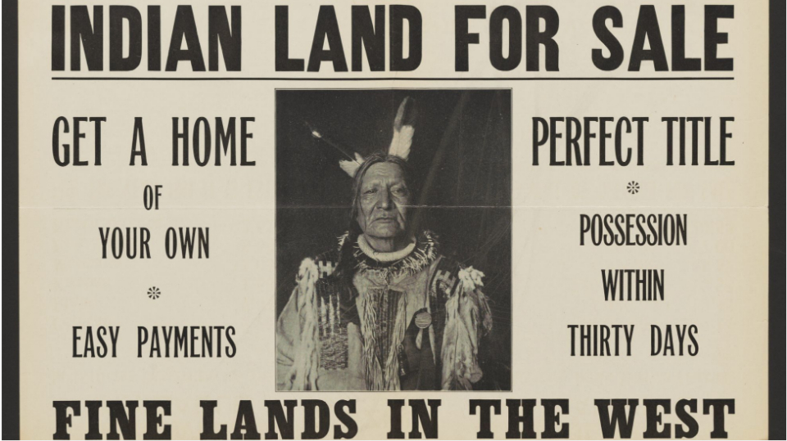A poster advertises an upcoming sale of stolen Indigenous land by the United States Department of the Interior in 1911. | Library of Congress (used to be)
The art of storytelling and learning history are the same, the only difference is the shifting of the cultural lens

Monsheeda (Dust Maker), and his wife Mehunga (Standing Buffalo), of the Ponca tribe, posed together in their wedding photo, circa 1900 (1850-1925)

HISTORY
History is a lesson into the complexities of the human mind in both beauty and horror.
So let us guide you into the complex ideas of history that continue to affect us to this day, so hopefully we can learn how to create a better tomorrow.

Starter Links:
Cultural Directory
World History
World Stories

Current Projects
The Undead: A Buried History
The Original Peoples History: Australia

Code 6: <p class="align-center"><span style="font-weight: 400; color: #ba372a;">The art of storytelling and learning history are the same, the only difference is the shifting of the cultural lens</span></p>
<figure class="post__image post__image--right" contenteditable="false"><img src="file:///C:/Users/jmrob/OneDrive/Documents/Publii/sites/decolonized-history/input/media/posts/7/Monsheeda-Dust-Maker-and-his-wife-Mehunga-Standing-Buffalo-of-the-Indigenous-Ponca-tribe-posed-together-in-their-wedding-photo-circa-1900-4.jpg" alt="" width="1000" height="990">
<figcaption contenteditable="true">
<p><span style="font-weight: 400;">Monsheeda (Dust Maker), and his wife Mehunga (Standing Buffalo), of the Ponca tribe, posed together in their wedding photo, circa 1900 (1850-1925)&nbsp;</span></p>
</figcaption>
</figure>
<h1>HISTORY</h1>
<p><span style="font-weight: 400;">History is a lesson into the complexities of the human mind in both beauty and horror.</span></p>
<p><span style="font-weight: 400;">So let us guide you into the complex ideas of history that continue to affect us to this day, so hopefully we can learn how to create a better tomorrow.</span></p>

The Guide To Stopping Colonialism

Understanding the Problem

Systematic Colonialism
Systematic Colonialism: To understand what Systematic Colonialism is, and how it works, Click Here

Making Change
To no ones surprise, the site advocating for decolonialization through understanding history, also believes we can make change today by doing what worked in the past.

What We Did Before

Maintaining Change

Creating an Educated Public
The ultimate guide to stopping colonialism is creating an educated general public who are well informed enough to not tolerate intolerance.
This goal is a long fought battle.
What is the methodology of Creating an Educated Public, Click Here
- What is the meaning of "radical"

The Hidden History of the United States

Colonialism Timeline
How Ethnicity Affects Appearance: Want to gain a true appreciation for the absurdity of White Supremacy, Click Here

Erased History
To Explore World History, Click Here

Why History Disappears
It's time for the generalized observation goggles. There are three types of "magically" disappeared History:
- Erased History
- Rewritten History
- Lost History

Erased History
- The act of burning a book (usually the motive behind the act is rewriting history)
Examples Throughout History:
- Queer History
- The All-Black towns of the Jim Crow era
Examples Today:
- Designating documents of violent crimes against undocumented immigrants as temporary (see SAA article for more details).
The difference between rewritten history and erased history is in how difficult recovery is and how it’s done.

Rewritten History
The most common trope used to rewrite history is White supremacy.
When the world gives you white supremacists, you viciously mock their rhetoric, or make them into lemonade.
Replacing the stories of anybody deemed to be "colored" with white narratives.
- Cultural Appropriation
- White-Washing
Rewritten History: To see how history gets rewritten and by who, Click Here.

Lost History
Lost History: To see how history just gets lost, Click Here

Rewritten History

Manipulated Documents Throughout History
Ever since there were documents there have been manipulated documents.
Examples:
- "Revealing the (corrupt) record in 14th-century Ireland" by The National Archives
- King Henry the 8th literally rewrote the Bible just so he could have a divorce.

White Supremacy
If there's one thing that all colonial forces have in common it's there need to spread white-supremacy through weirdly specific fantastical cliches about history.
The most common trope used to rewrite history is White supremacy.
When the world gives you white supremacists, you viciously mock their rhetoric, or make them into lemonade.

“Ancient White People” Trope
“Ancient White People”: To dive deep into some bs, Click Here

Will The Lies Ever End?
There's so many harmful provably false conspiracies, which is odd considering the most gut-wrenching conspiracies can be summed up as events that happened when you deep history.
The pure buffoonery that baffles any non-white supremacist.
Example:
- Multiple powerful people rewrote the Bible to suit there own needs.
- There were guide books to colonization that invaders would study to commit genocide.

Manipulation of Religion
Religions are meant to be a moral guide that evolves within and alongside the cultures that chose to follow.
Christianity was a major tool for colonialism and that’s why the religion is irreversibly linked to genocide and the erasure of history.
The main reason a religion is used to erase history is remove any choice but assimilation. Assimilate or die.
Examples:
- King Henry the 8th literally rewrote the Bible just so he could have a divorce.

The Two Big Issues With Religion:

Issue 1. Religion Is Based Off Interpretation
Religion can be manipulated through “reinterpretation” by those with selfish intent.
- Using religion as justification for genocide.
- Using religion to justify killing anyone who calls out the selfish actions of the wealthy.

Issue 2. Religion Is Too Sacred To Question
This is why it is so easy for corrupt powers to get away with 1.
Many religions create a hierarchy, where the devotees are at the lowest wrong and their God/s are at the top, leaving wiggle room for the wealthy or false mediators to come into the middle. And the mindset of ”how could an ant question god?” sets in and reflecting on reality becomes blasphemous for the general public.
- Using religion to rally an army out of the poor.
- Those who assimilate into the religion are often on the bottom rung of this hierarchy.
When both Issues occur they immediately strip a religion of any moral value, and make teaching new morals far harder.
So when you see civilizations throughout history that don’t separate their religion from their governance be violent hypocrites, it's because the religion was “reinterpreted” by selfish powers that wanted to be at the top of a fake hierarchy.

Lost History
Research Resources: To See History That's Still Available (Click Here)
I’m categorizing lost history as History that was lost without express intention. Lost history is primarily a victim of time or natural disaster, or even accidental human disaster.
Like a tsunami or an out of control fire because lil’ Timmy played with a matchbox, or maybe a group of people decided to migrate to a different land and their history is still buried in the ground of their original home.

Missing Land Masses

What About Colonial History
There is no situation under colonialism where history is lost, because there is no way to separate colonialism from the act of erasing history.
It’s hard to determine when history was just lost or erased, especially in the context of colonialism. The first example that comes to mind is the epidemics throughout the Americas after contact with Europe but much of the disease came after the invasion started not before, and was so devastating because of the conditions the original people of the land were put in by European invaders.

Systematic Colonialism

The Original Peoples History: Australia
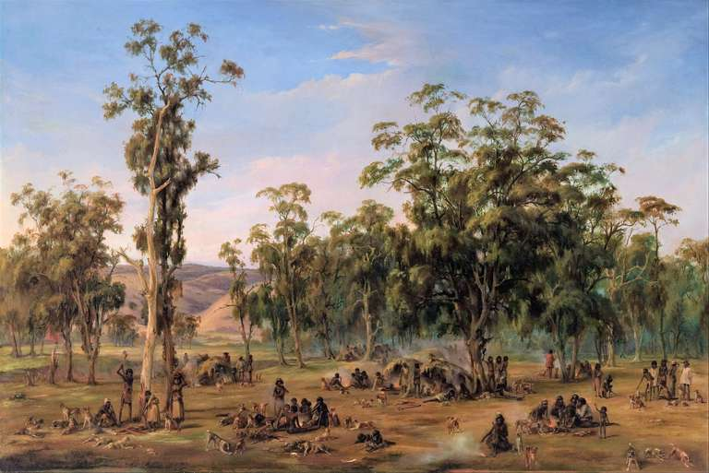An Aboriginal encampment near the Adelaide foothills in an 1854 painting by Alexander Schramm

Cultural Heads Up/ Trigger Warning
Aboriginal and Torres Strait Islander people should be aware that this project contains names, images, and voices of deceased persons.
Throughout this project I have done my best to find my information from indigenous sources when it comes to telling their history.
This is a heavy topic as it's about the attempted ethnic cleansing of the aboriginal people of Australia by the British and other European forces.
Around the world all Original Peoples have had to deal with colonial narratives overshadowing history.
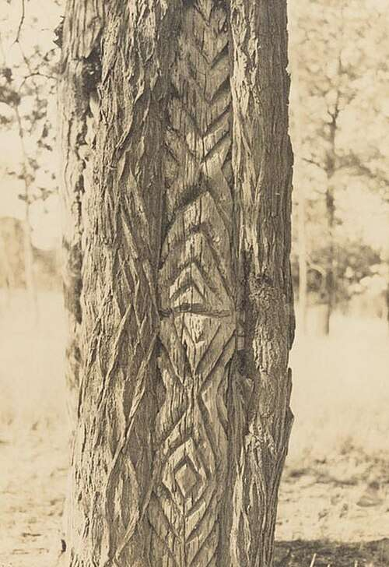Aboriginal carved tree, Clifton Cappie Towle c. 1925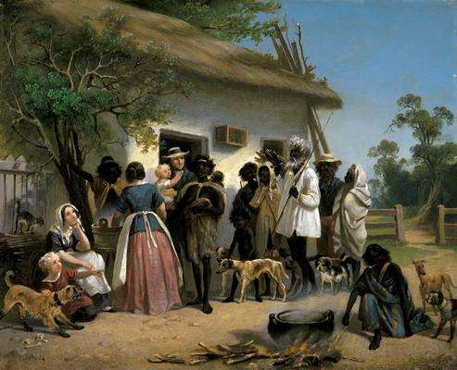Alexander Schramm - A scene in South Australia, 1850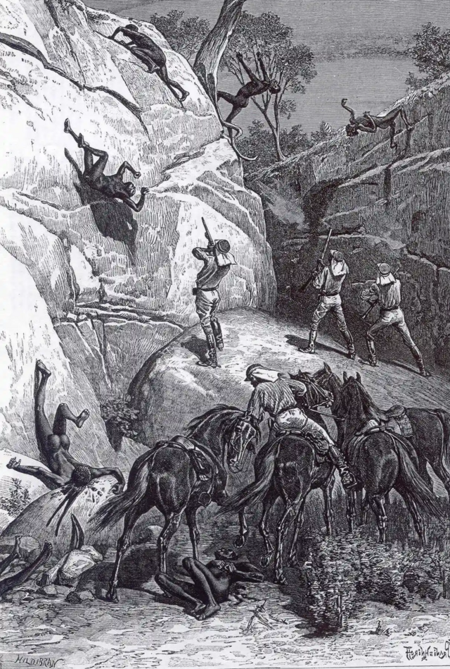Massacre at Skull Hole, Mistake Creek, Australia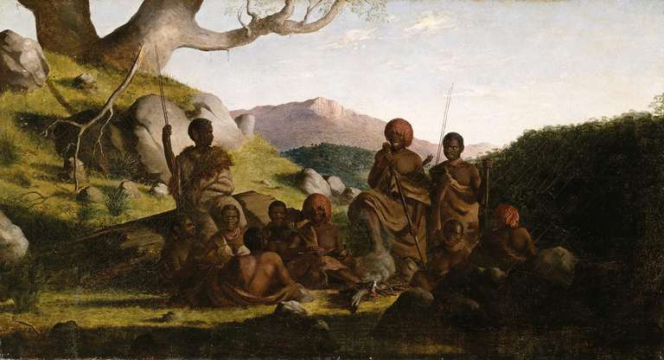Tasmanian Aborigines 1856–57, Robert Dowling. National Gallery of Victoria, Melbourne
“Aboriginal people are known to have occupied mainland Australia for at least 65,000 years. It is widely accepted that this predates the modern human settlement of Europe and the Americas.”
National Museum Australia, "Evidence of first peoples"
Australia’s colonization shows how the history being taught today is based off historical myths while the ancient stories of the fundamentals of the land are discarded, as tall tales because the creativity and figurative language that allowed for such histories to survive in the cultures memory is too different to understand.
Colonial historical myths are lies, while the more fantastical cultural stories are wells of metaphorical facts and knowledge and hold applied uses.

Cultures of Australia
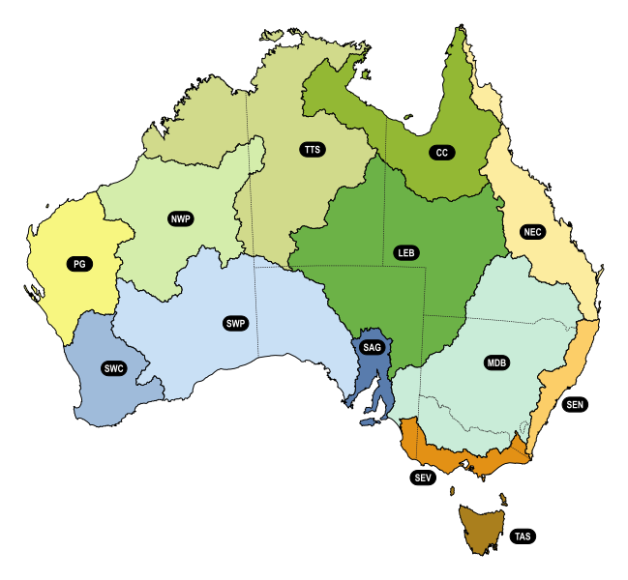Drainage Divisions of Australia
Cultural Directory: To see the many cultures of Australia organized by Drainage Division, Click Here

History

Stories

White Supremacy
How Ethnicity Affects Appearance: Want to gain a true appreciation for the absurdity of White Supremacy, Click Here

The Guide to Understanding the Zombi
The Zombi went from a representation of reality from both cultural story and traditional practice to the "White Zombie" for the Western Worlds entertainment.

Step 1. It All Begins with Racism Around Haitian Vodou
Haitian Vodou:

Research Resources

<p class="western"><span style="font-family: Bahnschrift, sans-serif;">All these sources are open unless specified otherwise.</span></p>
<div class="post__toc">
<h3>Table of Contents</h3>
<ul>
<li> </li>
<li><a href="#mcetoc_1j20c0vim10">Archives:</a></li>
<li><a href="#mcetoc_1j20c3l9l15">Libraries:</a></li>
<li><a href="#mcetoc_1j20c7u9t20">Websites:</a></li>
<li><a href="#mcetoc_1j20c7u9t21">Books:</a></li>
<li><a href="#mcetoc_1j20c7u9t22">Articles:</a></li>
<li><a href="#mcetoc_1j20ca4852n">Videos and Audio:</a></li>
<li><a href="#mcetoc_1j20ca4852o">Exhibition:</a></li>
</ul>
</div>
<h1 id="mcetoc_1j20bvvpun"></h1>
<h1 id="mcetoc_1j20c0vim10">Archives:</h1>
<p>A whole collection of resources within this whole collection of resources.</p>
<details>
<summary><strong>General Archives</strong></summary>
<ol style="list-style-type: upper-roman;">
<li>
<p class="western"><span style="font-family: Bahnschrift, sans-serif;"><a href="https://www.nationalarchives.gov.uk/" target="_blank" rel="noopener noreferrer">The National Archives</a>: General History</span></p>
</li>
<li><span style="font-family: Bahnschrift, sans-serif;"><a href="https://www.marxists.org/history/index.htm" target="_blank" rel="noopener noreferrer">Marxist History Archive</a>: Marxist History</span></li>
</ol>
</details>
<details>
<summary><strong>Journalist Magazines</strong></summary>
<p class="western">These are not your regular gossip columns, because this gossip is accurate history.</p>
<ol style="list-style-type: upper-roman;">
<li>
<p class="western"><a href="https://courier.unesco.org/en/archives" target="_blank" rel="noopener noreferrer">The UNESCO Courier's archives</a>: fascinating wide ranging open access archive of considerate.</p>
</li>
</ol>
</details>
<details>
<summary><strong>Indigenous Resources</strong></summary>
<ol style="list-style-type: upper-roman;">
<li><a href="https://archives.nctr.ca/ " target="_blank" rel="noopener noreferrer">National Centre for Truth and Reconciliation (NCTR) Archive</a>.</li>
<li> </li>
</ol>
</details>
<details>
<summary><strong>Other</strong></summary>
<ol style="list-style-type: upper-roman;">
<li><a href="https://archive.org/details/ciareadingroom" target="_blank" rel="noopener noreferrer">CIA Reading Room</a>: Archive of Released documents.</li>
</ol>
</details>
<h1 id="mcetoc_1j20c3l9l15">Libraries:</h1>
<p> </p>
<details>
<summary><strong>General Libraries</strong></summary>
<ol style="list-style-type: upper-roman;">
<li><span style="font-family: Bahnschrift, sans-serif;"><a href="https://palacebookshelf.dp.la/palace_bookshelf" target="_blank" rel="noopener noreferrer">Palace Bookshelf</a>: A free library, it does require a PDF reader</span><span style="font-family: Bahnschrift, sans-serif;">.</span></li>
<li><span style="font-family: Bahnschrift, sans-serif;"><a href="https://library.si.edu/books-online/topic" target="_blank" rel="noopener noreferrer">Smithsonian Library</a>: Variety </span></li>
<li> </li>
</ol>
</details>
<details>
<summary>Indigenous Resources</summary>
womp
</details>
<details>
<summary>Indigenous Language</summary>
womp
</details>
<h1 id="mcetoc_1j20c7u9t20" class="western"><span style="font-family: Bahnschrift, sans-serif;">Websites:</span></h1>
<p> </p>
<details>
<summary>Indigenous Resources</summary>
womp
</details>
<p> </p>
<h1 id="mcetoc_1j20c7u9t21" class="western"><span style="font-family: Bahnschrift, sans-serif;">Books:</span></h1>
<p> </p>
<details>
<summary>General Guides</summary>
womp
</details>
<details>
<summary>General Anti-Colonialism/ Anti-Imperialism</summary>
womp
</details>
<details>
<summary>Explicit History</summary>
For history that needs a trigger warning
<ol style="list-style-type: upper-roman;">
<li class="western"><i></i><a href="https://ia801503.us.archive.org/16/items/lindqvist-sven-exterminate-all-the-brutes-1997/Lindqvist%2C%20Sven%20-%20Exterminate%20All%20the%20Brutes%20%281997%29.pdf " target="_blank" rel="noopener noreferrer"><i>Exterminate all Brutes”</i> by Sven Lindqvist</a>: Expose of how genocidal thought isn’t unthinkable.</li>
</ol>
</details>
<details>
<summary>Original Peoples History: North America</summary>
North America<details>
<summary>Indigenous Authors: North America</summary>
womp
</details>
</details>
<details>
<summary>Original Peoples History: South America</summary>
South America<br>
<details>
<summary>Indigenous Authors: South America</summary>
<ol style="list-style-type: upper-roman;">
<li class="western"><i></i><a href="https://archive.org/details/aztecthoughtcult0000leon" target="_blank" rel="noopener noreferrer"><i>Aztec </i><i>T</i><i>hought and </i><i>C</i><i>ulture; a study of the ancient Nahuatl</i> <i>mind</i> by Miguel León Portilla</a>: Takes a genuine consideration for the Aztec people.</li>
</ol>
</details>
</details>
<details>
<summary>Original Peoples History: Australia</summary>
Australia<br>
<details>
<summary>Indigenous Authors: Australia </summary>
<ul>
<li><span style="font-family: Bahnschrift, sans-serif;">David Unaipon: Storyteller</span></li>
</ul>
</details>
</details>
<details>
<summary>Original Peoples History: Africa</summary>
Africa<br>
<details>
<summary>African Authors</summary>
For history that needs a trigger warning.
</details>
</details>
<p> </p>
<p> </p>
<h1 id="mcetoc_1j20c7u9t22" class="western"><span style="font-family: Bahnschrift, sans-serif;">Articles:</span></h1>
<p> </p>
<details>
<summary>General Guides</summary>
womp<details>
<summary>General </summary>
womp
</details>
</details>
<details>
<summary>General Anti-Colonialism/ Anti-Imperialism</summary>
womp<details>
<summary>Heading</summary>
womp
</details>
</details>
<details>
<summary>Original Peoples History: North America</summary>
womp<details>
<summary>Indigenous Authors: North America</summary>
womp
</details>
</details>
<details>
<summary>Original Peoples History: South America</summary>
womp<details>
<summary>Indigenous Authors: South America</summary>
womp
</details>
</details>
<details>
<summary>Original Peoples History: Australia</summary>
womp<details>
<summary>Indigenous Authors: Australia </summary>
womp
</details>
</details>
<details>
<summary>Explicit History</summary>
womp
</details>
<p> </p>
<h1 id="mcetoc_1j20ca4852n" class="western"><span style="font-family: Bahnschrift, sans-serif;">Videos and Audio:</span></h1>
<p> </p>
<details>
<summary>General Videos and Audio</summary>
<ol style="list-style-type: upper-roman;">
<li><span style="font-family: Bahnschrift, sans-serif;"><a href="https://www.pbs.org/" target="_blank" rel="noopener noreferrer">PBS:</a> Huge variety of shows</span></li>
</ol>
</details>
<details>
<summary>Original Peoples Documentaries</summary>
womp
</details>
<details>
<summary>YouTube</summary>
womp<details>
<summary>Channels</summary>
<ol style="list-style-type: upper-roman;">
<li>Lore Lodge: Thorough deep dives folklore and Missing 411.</li>
<li>Today I Found Out: Variety of topics.</li>
<li>Into the Shadows: Variety of dark topics.</li>
<li>Decoding the Unknown: Breaking down mysteries and conspiracies.</li>
<li>Highlight History: History.</li>
</ol>
</details>
<details>
<summary>Videos</summary>
womp
</details>
</details>
<p> </p>
<h1 id="mcetoc_1j20ca4852o">Exhibition:</h1>
<p> </p>
<details>
<summary>General Exhibitions</summary>
<ol style="list-style-type: upper-roman;">
<li><a href="https://www.nelsonmandela.org/exhibitions" target="_blank" rel="noopener noreferrer">Nelson Mandela Foundation</a></li>
</ol>
</details>
<details>
<summary>Original Peoples History: North America</summary>
<ol style="list-style-type: upper-roman;">
<li><span style="font-family: Bahnschrift, sans-serif;"><a href="https://dp.la/exhibitions/history-of-survivance/ancient-legacies" target="_blank" rel="noopener noreferrer">History of Survivance</a>: Upper Midwest 19th-Century Native American Narratives, </span><span style="font-family: Bahnschrift, sans-serif;">DPLA</span></li>
</ol>
</details>
<details>
<summary>Original Peoples History: South America</summary>
womp
</details>
<details>
<summary>Original Peoples History: Australia </summary>
womp
</details>
<details>
<summary>Original Peoples History: Africa</summary>
womp
</details>
<hr>
<h1>Unreliable Sources: </h1>
<p class="align-center">(Organized Alphabetically)</p>
<table style="border-collapse: collapse; width: 138.319%; height: 405.5px;" border="1">
<tbody>
<tr style="height: 48.5625px;">
<td style="width: 25.0512%; height: 48.5625px;" width="140">Name:</td>
<td style="width: 38.7643%; height: 48.5625px;" width="227">Which Documents:</td>
<td style="width: 36.0831%; height: 48.5625px;" width="208">Why Their Unreliable:</td>
</tr>
<tr style="height: 75.5625px;">
<td style="width: 25.0512%; height: 75.5625px;">David Paulides</td>
<td style="width: 38.7643%; height: 75.5625px;">All works</td>
<td style="width: 36.0831%; height: 75.5625px;">Fabricates facts and leaves out information.</td>
</tr>
<tr style="height: 38.5625px;">
<td style="width: 25.0512%; height: 38.5625px;">Henry David Thoreau</td>
<td style="width: 38.7643%; height: 38.5625px;">All Works</td>
<td style="width: 36.0831%; height: 38.5625px;">No Regard for Indigenous Stories</td>
</tr>
<tr style="height: 48.5625px;">
<td style="width: 25.0512%; height: 48.5625px;" width="140">Madison Grant</td>
<td style="width: 38.7643%; height: 48.5625px;" width="227"><em>The Conquest of a Continent </em>(1933)</td>
<td style="width: 36.0831%; height: 48.5625px;" width="208">Racist Eugenicist</td>
</tr>
<tr style="height: 48.5625px;">
<td style="width: 25.0512%; height: 48.5625px;" width="140">William Ramsay Smith</td>
<td style="width: 38.7643%; height: 48.5625px;" width="227">All Works</td>
<td style="width: 36.0831%; height: 48.5625px;" width="208">Plagiarism</td>
</tr>
<tr style="height: 48.5625px;">
<td style="width: 25.0512%; height: 48.5625px;" width="140"> </td>
<td style="width: 38.7643%; height: 48.5625px;" width="227"> </td>
<td style="width: 36.0831%; height: 48.5625px;" width="208"> </td>
</tr>
<tr style="height: 48.5625px;">
<td style="width: 25.0512%; height: 48.5625px;" width="140"> </td>
<td style="width: 38.7643%; height: 48.5625px;" width="227"> </td>
<td style="width: 36.0831%; height: 48.5625px;" width="208"> </td>
</tr>
<tr style="height: 48.5625px;">
<td style="width: 25.0512%; height: 48.5625px;" width="140"> </td>
<td style="width: 38.7643%; height: 48.5625px;" width="227"> </td>
<td style="width: 36.0831%; height: 48.5625px;" width="208"> </td>
</tr>
</tbody>
</table>

Haitian Vodou
By Kaitlyn Powell
August 5, 2025
Media and fiction has done this religion dirty
Many of these stories are religious allegories. When I say Spiritualism I’m not referring to boho misappropriation, I’m referring to the history of a specific culture's religious identity. We’re talking about complicated stuff here.
Terminology:
Oungan - A Vodou Priest.
Mambo - A Vodou Priestess.
Bokor - A Vodou Priest who practices in a negative way; similar to the indigenous idea of bad medicine.
Lwa or Loa - at its most basic a spiritual force.
Bondye - The creator of the universe, and has a deep connection to the Gwo-bon-anj.1
Veve - “the geometric symbol of the appropriate lwa”

Voodoo, Hoodoo, you do… need to fuck off.
It all starts with Vodun from west Africa. Then during the Trans-Atlantic Slave Trade Vodun was taken to Haiti and New Orleans.
From Haiti Vodun developed into Haitian Vodou.
From New Orleans Vodun developed into Voodoo.
As Adam M. McGee always says:
“Vodou and voodoo have entwined destinies, and Vodou will continue to suffer from ill repute as long as voodoo remains an outlet for the expression of racist anxieties.”2
Adam M. McGee does clarify that Voodoo with a capital V is “Voodoo by religious reconstructionists in New Orleans” which actually has cultural backing unlike lower case voodoo (McGee, 233).2
Hoodoo however
More broadly, it’s a part of a collection of spiritual and healing traditions that have come to the United States by way of the Trans-Atlantic Slave Trade. Ancestor worship is part of the larger collection of spiritual traditions of the United States, popularly known as Conjure or Hoodoo. We want to be sure to keep the memory of our ancestors alive. And so we continue to call their name, we continue to celebrate them.3
-Kameelah Martin Ph.D
Before I can properly explain what Vodou is, we have to cover what it is not.

How The Image of Vodou Changed
Bastardizing cultures and religions have direct consequences for those cultures and religions.
The story of what white-washed bastardization did to Marie Laveau should piss you off. Marie Laveau, a successful black woman in the 1800’s, who valued and saved lives had her grave repeatedly desecrated by westerners for its relation to voodoo.
Marie Laveau’s life, Click Here
Gerdes Fleurant, a teacher and scholar of Applied Ethnomusicology, and Haiti’s representative at the International Council for Traditions of Music and Dance (ICTMD), explains that;
Popular labeling of Vodou as "witchcraft" and "magic" has been a historical tradition among European colonialists, and Hollywood films and supermarket tabloids sustain the myths. Yet Vodou is essentially a monotheistic religion, which recognizes a single and supreme spiritual entity or God. Besides Vodou's visible cultural and ritual dimensions expressed through the arts-especially in Haitian music and dance-its teaching and belief system include social, economic, political, and practical components. Today, for example, Vodou's basic teachings are concerned with what can be done to overcome the limiting social conditions of Haiti- what to do in case of illness in a country that counts only one physician for every 23,000 people, and what to do before embarking upon major undertakings, such as marriage, business transactions, or traveling abroad. Vodou gives its adherents positive means to address these issues.4

The Christians Didn't Like Vodou
All the colonial powers were some sect of Christianity. Different sects of Christianity and the Abrahamic religions as a whole have never gotten along well despite believing in the same fundamental ideas - So how would a very different religion that has been around three times longer (around 6000 years) compare to Christianity (2000 years)?
The answer, bad, very bad.
Though today Vodou, Voodoo, and Hoodoo all find syncretism with Christianity, this was an assimilate or die situation

Possession
What was one of Colonial Europe's greatest fears, that goes by the same name of it’s greatest goal - Possession (in this case the spiritual kind)
Connection to the Lwa is often experienced through possession.
“The people transcend their materiality by becoming spirits, and the spirits renew their vigor by dancing and feasting with the chwal, or horses, for it is said that during possession the lwa rides a person like a cavalier rides a horse.”4
The possession is more so a deep connection to the spirits in an expression of cultural joy and celebration.
This does not mesh with the Christian Interpretation of possession, leading to the false narrative that Vodou leads to you getting possessed by the devil
To be frank I personally find the idea of being ‘taken over by the holy spirit’ and ‘speaking in tongues’ far more weird.

The Idea of Witch Craft
You mean the depictions of witchcraft meant to demonize any form of religious and spiritualistic expression outside the oligarchy wasn’t an accurate representation of cultural practice?
Much of witchcraft around the world has been about manipulating the senses and mind to create an illusion of connecting to something outside of the conscious mind; good, bad, or neutral.
Other times it's just herbology.
‘Witchcraft’ is not about evil magic, ‘witchcraft’ is about psychological ‘magic’ within a culture's belief system. The physical potions recipes of witchcraft are usually legend, subject to change, while the cultural belief in magic and magical practices are sacred.
So when examining something as complex as Haitian Vodou we must see “that this was not a black magic cult, but this was an amazing complex metaphysical world” (part 6 Wade Davis).6
One of the first things a Westerner is going to notice about Vodou is the Christian imagery, and the historical implication of colonialism is correct. There are two reasons Catholic elements appear in Vodou:

Bibliography
- The Faces of the gods : vodou and Roman Catholicism in Haiti by Desmangles, Leslie Gérald
- Adam McGee
- Kameelah Martin Ph.D, “Uncovering the Power of Hoodoo: An Ancestral Journey”, PBS Voices, YouTube
- Gerdes Fleurant, "Vodou", https://folklife-media.si.edu/docs/festival/program-book-articles/FESTBK2004_04.pdf
- The Faces of the Gods, https://archive.org/details/facesofgodsv00desm/page/74/mode/2up?q=veve
- Wade Davis
This article was updated on August 7, 2025

Race: A Profitable Myth
By Kaitlyn Powell
August 2, 2025
Simply put "Race" is a social construct.
No clear and unequivocal evidence of racism has been found in other cultures or in Europe before the Middle Ages - George M. Fredrickson
"Race" is meant to categorize people who share biological traits that society deems important. Even before examining how inaccurate the categories are, the purpose itself lacks any and all scientific thought.

How Biology Proves "Race" is a Myth
The fundamental facts of biology proves there is no such thing as race.

"Race", Ethnicity and Heritage
"I don't see race" well it's hard to see something that doesn't exist, but we can see ethnicity and acknowledge heritage.

- How racism is real without the concept of race being real

How History Proves "Race" is a Myth

- In the early 1900s, any White person who was NOT a Anglo-Saxon Protestant was classified as NOT White.

Bibliography

This article was updated on August 7, 2025

How Ethnicity Affects Appearance
By Kaitlyn Powell
August 1, 2025
- melanin
This article was updated on August 7, 2025

“Ancient White People”
By Kaitlyn Powell
August 1, 2025
How Ethnicity Affects Appearance: Want to gain a true appreciation for the absurdity of White Supremacy, Click Here
This stupid trope claims that the Original People of the land were preceded by “superior white races” ; it is a theory so thoroughly dunked in dung that it often coincides with the “It was aliens” trope.
A common trope of erasing history is the “ancient white people” trope, where white anthropologists and archeologists go “these old bones look white so they must be caucasian”.
“The theory of violent and disruptive population replacements in the "prehistorical" past is well known since late eighteenth-century U.S. archaeology; it has been used for explaining the “mysterious" disappearance of the Maya as well as that of the "Mound Builders.' Its cultural work consists in making the European conquest of America and genocidal policies toward the Indigenous population seem less unprecedented, perhaps even a matter of historical justice. Its similarity with the alt-right's ideological narrative of population replacement and "white genocide" is uncanny.”
- Decolonized "Prehistory": Deep Time and Indigenous Knowledges in North America by Gesa Mackenthun and Christen Mucher

"The Ancient One"
Paleo-American man found in 1996 on the Columbia River in Kennewick Washington. “The Ancient one”

The "Cheddar Man"
The "Cheddar Man from New England found in 1903 was likely brown.

"Red Paint People"
The story of "Red Paint People" treats Algonquian people as foreigners to a previous white 'superior' predecessor.

"It Was Aliens" Trope
Who new aliens would have the same values as white-supremacists according to white-supremacists.

Book Recommendation
- Decolonizing “Prehistory” : Deep Time and Indigenous Knowledges in North America by Gesa Mackenthun, Christen Mucher

This article was updated on August 7, 2025

Creating an Educated Public

Why Maps Lie
By Kaitlyn Powell
July 31, 2025
Why Maps Lie: To learn why world maps are inaccurate and what affect that has had on our world view

https://equal-earth.com/equal-earth-projection.html
This article was updated on August 7, 2025

Common Arguments
By Kaitlyn Powell
July 30, 2025
- Statements on an issue that are said to overshadow said issue
- White people want to be the victim because the alternative in their eyes is worse
- refusal to acknowledge

"White People Didn't Invent Slavery"

- "White men weren't the only ones who profited from slavery"
- "White people were slaves throughout history too"
- "Black people owned slaves too"

"Colonialism Ended"
- systemic colonialism

- "I've struggled too, so I'm not privileged"
- "Racism ended with slavery"
- "I've never enslaved/colonized anyone"
- "White-privilege is a illusion"
- "Minorities have gotten special privileges that white people don't have"

"Why is Racism towards White People Okay"
- "why is casual white racism acceptable?"
much of what is called racism towards white people is actual criticisms disguised in a matter to mock, because laughter is medicine.
- "Why does my opinion as a white person, not matter"
When it comes to issues centring around an ethnicity you are not
It's not about you and it shouldn't be about you, you don't have the required experience to comment.
- "Everything is made to be about race these days"
- "The most racist people in the world are [race]"

"It isn't about race"

"I'm friends with [race] people so I can't be racist"
believing everyone is a monolith
- "I'm partially [race], so I can't be racist"
- "But, I'm not a bad person"
- "My black friend said I could say it"
It becomes more about proving 'I as a white person am not racist because...' rather then the real affects of racism.

"I own this land"
"I am a taxpaying citizen and their an illegal immigrant"

This article was updated on August 7, 2025

The Guide to Understanding History
By Kaitlyn Powell
July 30, 2025

Guide to Understanding Timelines

Documentation of History
- Oral History
- Art History
- Written History

Misconceptions
Common Arguments: To learn the nuance behind common arguments, why some some "debates" lack logic, Click Here

This article was updated on August 7, 2025

editing
By Kaitlyn Powell
July 24, 2025
Journalist Magazines

This article was updated on August 7, 2025

